 | Faculty of Computing and AI, Air University, Islamabad  Department of Creative Technologies  Software Engineering | 

FRACTAL

By

Ahmad Hassan FA22-BSSE-221775
Faraz Ashraf FA22-BSSE-221847

Supervisor
Dr. Iqbal Murtza

Bachelor of Science in Software Engineering (2022-2026)

The candidate confirms that the work submitted is their own and appropriate
credit has been given where reference has been made to the work of others.

 | Faculty of Computing and AI, Air University, Islamabad  Department of Creative Technologies  Software Engineering | 

FRACTAL

A project presented to
AIR University, Islamabad

In partial fulfillment
of the requirement for the degree of

Bachelor of Science in Software Engineering (2022-2026)

By

Ahmad Hassan 221775
Faraz Ashraf 221847

DECLARATION

We hereby declare that this software, neither whole nor as a part, has been copied out from any source. It is further declared that we have developed this software and accompanied report entirely based on our personal efforts. If any part of this project is proved to be copied out from any source or found to be reproduction of some other, we will stand by the consequences. No Portion of the work presented has been submitted of any application for any other degree or qualification of this or any other university or institute of learning.

Student Name 1 Student Name 2

Ahmad Hassan Faraz Ashraf

FA22-BSE-221775/ISB FA22-BSE-2218475/ISB

CERTIFICATE OF APPROVAL
It is to certify that the final year project of BS (SE) “FRACTAL” was developed by
Ahmad Hassan (CIIT/FA22-BSE/TN-221775) and Faraz Ashraf (CIIT/FA22-BSE/TN-221847) under the supervision of “Dr. Iqbal Murtza” and that in their opinion; it is fully adequate, in scope and quality for the degree of Bachelors of Science in Software Engineering.


--------------------------------------
Supervisor

---------------------------------------
External Examiner

---------------------------------------
Head of Department
(Department of Computer Science)

Executive Summary
The increase in innovation demands an increase in computation resources like GPUs, which are prohibitively expensive and are not suitable for an average independent user or a small company. Existing solutions are centralized to specific devices that are fewer in number, have a static location, and have high battery consumption. Meanwhile, the billions of handheld devices remain idle, wasting an unfathomable amount of combined computation power every second. The billions of these handheld devices remain idle, wasting an unfathomable amount of combined computation power every second. The data centers used for computation require water for cooling and increase of water use for data centers of Microsoft increases from 6.4 million cubic meters to 7.8 from 2022 to 2023. There is an urgent need for innovative strategies for energy-efficient infrastructure to mitigate the data centers' impact on the environment “FRACTAL” a decentralized distributed computation harvesting platform proposed address the gap by developing computing platform that utilize the computation power of mobile devices. Th system consists of two modules, one is client side module that involves the participation of mobile devices that provide computation for model training, preprocessing and resource allocation, and other server-side modules that handles the management, database, model aggregation, and task allocation to the devices. By shifting computation paradigms to mobile devices, we reduce the reliance on cost-effective data centers either entirely or partially, contribute to global sustainability efforts by reducing the reliance on huge data centers that lead to carbon emissions, high resource consumption, etc., and utilize computational resources at every possible opportunity. The key benefit of the product is that it provides access to high computation resources, making it accessible for an average independent user or a small company, promoting global sustainability by reducing high infrastructure dependency.

Acknowledgement
All praise is to Almighty Allah who bestowed upon us a minute portion of His boundless knowledge by virtue of which we were able to accomplish this challenging task.

We are greatly indebted to our project supervisor “Dr. Iqbal Murtza”. Without their personal supervision, advice and valuable guidance, completion of this project would have been doubtful. We are grateful to them for their encouragement and continual help during this work.

And we are also thankful to our parents and family who have been a constant source of encouragement for us and brought us with the values of honesty & hard work.

Student Name 1 Student Name 2

Ahmad Hassan Faraz Ashraf

Abbreviations
zkVM | Zero knowledge virtual machine
BOINC | Berkeley open infrastructure for network computing
SRS | Software Requirement Specification
SDD | Software design document
ML | Machine learning
OS | Operating system
CKPT | Checkpoint
MVC | Model View Controller

Table of Contents
1 Introduction 13
1.1 Vision Statement 13
1.2 Related System Analysis/Literature Review 13
1.3 Project Deliverables 15
1.4 System Limitations/Constraints 16
1.5 Tools and Technologies 16
1.6 Relevance to Course Modules 17
2 Problem Definition 18
2.1 Problem Statement 18
2.2 Problem Solution 19
2.3 Objectives of the Proposed System 19
2.4 Scope 20
2.5 Modules 21
3 Requirement Analysis 23
3.1 User classes and characteristics 23
3.2 Requirement Identifying Technique 24
3.3 Functional Requirements 25
3.3.1 Functional Requirement 1 25
3.3.2 Functional Requirement 2 26
3.3.3 Functional Requirement 3 26
3.3.4 Functional Requirement 4 27
3.3.5 Functional Requirement 5 27
3.3.6 Functional Requirement 6 28
3.3.7 Functional Requirement 7 28
3.3.8 Functional Requirement 8 29
3.3.9 Functional Requirement 9 29
3.3.10 Functional Requirement 10 30
3.3.11 Functional Requirement 11 30
3.3.12 Functional Requirement 12 31
3.3.13 Functional Requirement 13 31
3.3.14 Functional Requirement 14 32
3.3.15 Functional Requirement 15 32
3.3.16 Functional Requirement 16 33
3.3.17 Functional Requirement 17 33
3.3.18 Functional Requirement 18 34
3.3.19 Functional Requirement 19 34
3.3.20 Functional Requirement 20 35
3.3.21 Functional Requirement 21 35
3.3.22 Functional Requirement 22 36
3.3.23 Functional Requirement 23 36
3.4 Non-Functional Requirements 37
3.4.1 Reliability 37
3.4.2 Usability 37
3.4.3 Performance 37
3.4.4 Security 38
3.5 External Interface Requirements 38
3.5.1 User Interfaces Requirements 38
3.5.2 Software interfaces 39
3.5.3 Communications interfaces 40
4 Design and Architecture 41
4.1 Architectural Design 41
4.2 Design Models 1
4.3 Data Design 34
4.3.1 Data Dictionary 35
4.4 Human Interface Design 37
4.4.1 Screen Objects and Actions 42
4.4.2 Objects 42
4.4.3 Actions 42
5 Implementation 43
5.1 Algorithm 43
5.2 User Interface 45
6 Testing and Evaluation 52
6.1 Unit Testing 52
6.2 Functional Testing 53
6.3 Business Rules Testing 54
6.4 Integration Testing 55
7 Conclusion and Future Work 56
7.1 Conclusion 56
7.2 Future Work 57
8. References 58

List of Tables & Figures

Table 1: Related System Analysis with Proposed Project Solution 12
Table 2: Tools and Technologies for Proposed Project 14
Table 3: User classes and characteristics 21
Table 4: Event response table 22
Table 5: FR1 24
Table 6: FR2 24
Table 7: FR3 25
Table 8: FR4 25
Table 9: FR5 25
Table 10: FR6 26
Table 11: FR7 26
Table 12: FR8 27
Table 13: FR9 27
Table 14: FR10 28
Table 15: FR11 28
Table 16: FR12 29
Table 17: FR13 29
Table 18: FR14 30
Table 19: FR15 30
Table 20: FR16 31
Table 21: FR17 31
Table 22: FR18 32
Table 23: FR19 32
Table 24: FR20 33
Table 25: FR21 33
Table 26: FR22 34
Table 27: FR23 34
Table 28: Event response table 9
Table 29: Algorithm 44

Figure 1: Box and line diagram 43
Figure 2: Architecture diagram 44
Figure 3: APP Interface 1 1
Figure 4: APP Interface 2 2
Figure 5: APP Interface part3 2
Figure 6: APP Interface 3 2
Figure 7: APP Interface 5 3
Figure 8: APP Interface 4 3
Figure 9: APP Interface complete 4
Figure 10: APP Interface 5
Figure 11: Resource management 5
Figure 12: Interface 6
Figure 13: App Global 7
Figure 14: ER1-Activity diagram 10
Figure 15: ER1 system sequence diagram 11
Figure 16: ER1 State transition diagram 11
Figure 17: ER2 Activity diagram 12
Figure 18: ER2 System sequence diagram 13
Figure 19: ER2 State machine diagram 14
Figure 20: ER3 Sequence diagram 14
Figure 21: ER3 Activity diagram 15
Figure 22: ER3 State machine diagram 16
Figure 23: ER4 State machine diagram 16
Figure 24: ER4 Activity diagram 17
Figure 25: ER4 System sequence diagram 18
Figure 26: ER5 State machine diagram 18
Figure 27: ER5 Activity diagram 19
Figure 28: ER5 System sequence diagram 20
Figure 29: ER6 Activity diagram 21
Figure 30: ER6 System sequence diagram 22
Figure 31: ER7 Activity diagram 23
Figure 32: ER7 Sequence diagram 24
Figure 33: ER7 State machine diagram 24
Figure 34: ER8 Activity diagram 25
Figure 35: ER8 Sequence diagram 26
Figure 36: ER9 Activity diagram 27
Figure 37: ER9 System sequence diagram 28
Figure 38: ER9 State machine diagram 29
Figure 39: ER10 Activity diagram 30
Figure 40: ER10 System sequence diagram 31
Figure 41: ER10 State machine diagram 31
Figure 42: ER11 Activity diagram 32
Figure 43: ER11 Sequence diagram 33
Figure 44: ER11 State machine diagram 34
Figure 45: ERD diagram 35
Figure 46: Home 38
Figure 47: Setting 38
Figure 48: Active 39
Figure 49: Model training 39
Figure 50: Device insight screen 40
Figure 51: Usage insight screen 40
Figure 52: Status screen 41
Figure 53: Registration screen 41
Figure 54: About US UI 46
Figure 55: Device Insight UI 46
Figure 56: Device registration UI 47
Figure 57: Forget password UI 47
Figure 58: Active UI 48
Figure 59: Inactive UI 48
Figure 60: Model training UI 49
Figure 61: Registered Info UI 49
Figure 62: Unregister UI 50
Figure 63: Setting UI 50
Figure 64: Heartbeat UI 51

Introduction
Fractal is a decentralized distributed computing platform that will utilize the computational power of android mobile devices. Based on current progress and completed modules, project successfully implemented the development of a mobile side application package, application package load, loading of model, in device training, initialization of weight and bias, interpreter loading, data array creation and training of fixed tasks. All the progress reflects the core innovation of the project enabling training on mobile-on-mobile devices

Vision Statement
For AI/ML companies, research institutions, independent developers, tech startups, and small, medium, and large enterprises that require extensive computing needs for their high computation intensive tasks/projects, the decentralized distributed computation harvesting platform is a mobile based application that utilizes the computation power of mobile devices (primarily Android devices) to provide cloud computation services. Unlike traditional computation solutions such as CPU/GPU farms, which are prohibitively expensive and are not suitable for an average independent user or a small company, our software will enable low-cost, scalable, yet powerful computing services as a unified computation unit. This will eliminate the need for multimillion CPU/GPU farms, reducing the cost of high-performance computations significantly. Utilizing the decentralized approach will result in lower infrastructure dependency, fault tolerance, sustainability, and an eco-friendly computation harvesting environment.

Related System Analysis/Literature Review
Systems related to our proposed projects are provided below
- In Yokohama, Japan, a conference took place in which some researchers published a paper in which they propose a distributed machine learning system, i.e., virtual data centers with electric vehicles, which includes electric cars parked in parking lots, hybrid LAN, and central servers(Bai, Jia, Deng, & Dong, 2024).This distributed machine learning system aims to utilize the computational power of electric cars parked in parking lots for model training.
- BOINC is an open-source software platform for computing using volunteer resources (Anderson., n.d.). BOINC is designed especially for computer owners. Computer owners participate in the BOINC projects and monitor how their resources are allocated
- The Nexus network is a verifiable supercomputer that combines the computational power of worldwide devices into single computers (Marin, n.d.). With Nexus zkVM, a zero-knowledge virtual machine instance, each node supplies computation. In the zkVM 3.0 update, users earn nex points by providing computation.

Table 1: Related System Analysis with Proposed Project Solution
Application Name | Weakness | Proposed Project Solution
BOINC | Volunteering computing is only for computer owners  No federated learning | Our proposed project utilizes mobile devices and designs for federated learning, allowing model training with the exchange of model updates, offering privacy and efficiency
NEXUS | Require high-power devices for computation  High battery consumption due to zk proof (verification process) | Our proposed project with TensorFlow offers better support for Androids also it offers adaptive model updates and selective participation to weak devices and federated learning, allowing model training with exchange of model
 |  | updates instead of raw which leads to less battery consumption.
Distributed machine learning system (DMLS) | Distributed machine learning systems are limited to electric vehicles only, with limited scalability due to only 40 million vehicles, of which  17.1 million are smart cars. Static location for computation | Our proposed project utilizes mobile devices that number more than 6.8 billion now, so there are no scalability constraints, limitations, or easy accessibility. Dynamic network and independent of location constraint

Project Deliverables
The project deliverables are provided below:
- Client side application
- Software requirement specification document (SRS)
- Software design document (SDD)
- Final report
- Final presentation

System Limitations/Constraints
- Network Latency
The system depends on communication between devices and servers for task allocation, model aggregation, etc. Any kind of lag or delay in communication impacts the model training efficiency.
- Device availability and computation fluctuations
Device and computation power availability or consistency is unpredictable; computation power is not guaranteed at any time; it may fluctuate, so the availability of the device may be turned off by the user or disconnected due to network issues.
- Software and compatibility issues
The system working depends on software such as TensorFlow Lite, Kotlin libraries, etc., which may not be available for all devices. These may not be backward or forward compatible, thus leading to complicated version issues.
- Dependency on device-specific optimization
Devices differ in their capabilities, such as CPU, RAM, battery, etc., which results in inconsistent training power. For smooth work, the system must dynamically adapt to the device's capabilities, which is also a challenge on firmware, legacy, and hardware levels.
- Platform Fragmentation
The diversity in devices’ hardware capabilities and operating systems makes it difficult for single-fit work mechanisms. For smooth work, the system is required to dynamically accommodate differences.

Tools and Technologies
The tools and technologies for the implementation of the proposed project are given below:

Table 2 Tools and Technologies for Proposed Project
Tools  And  Technologies | Tools | Version | Rationale
 | Android Studio | latest | IDE for Android App  Development
 | Firebase | latest | Backend Services
 | Figma | latest or 125.2.3 | Design Work
 | Technology | Version | Rationale
 | Python | 3.11 or 3.12 ++ | Backend Processing
 | Kotlin | 2.0.20 | App Development
 | TensorFlow | 2.18 | Create ML models
 | TensorFlow Lite | latest | Deploy ML models on devices
 | Firebase Fire store | latest | Database
 | Firebase Authentication | latest | Authentication
 | Firebase Cloud Functions | latest | Server logic

Relevance to Course Modules
Fractal a decentralized distributed computation harvesting system is the combination of all the courses we studied during bachelors (BSSE).
- Programming fundamentals & OOP helps us in structuring and reusable of our code with concepts of encapsulation, class, inheritance, polymorphism etc.
- SDA and SCD help with architectural design of the system that uses such as MVC.
- Software project management, software quality management and software metrics ensure the quality and timely delivery of FYP 1, FYP2, FYP proposal and FYP3.
- Human computer interaction helps us in designing our UI to make it more efficient, accessible and usable.
- Mobile application development helps us to be aware of the Firebase fire store, firebase authentication and Android studio as these are the key tools and technologies
- So as do many other courses like Probability and statistics, OS and computer network etc.

Problem Definition
This section discusses the increase in computation needs within the past years, and the effect of the ways used to get this computation. Also, this section discussed the solution to these problems and the objectives of the proposed solution

Problem Statement
With the linearly increasing innovation, the computation needs are increasing exponentially. The computational power needed to train AI is now rising seven times faster than ever (Adnan Mehonic, 2021). From 1959 to 2012, the amount of computation to train AI models doubled every two years, which after 2012 shortened to every 3.4 months. This means computation to train AI models increases by a factor of 2 every 3.4 months (Thomas Gabor, 2020). Now, the number of phone users has reached 6.8 billion, and this shows that 86% of the world's population has at least one cell phone (Aslan, 2023). The billions of these handheld devices remain idle, wasting an unfathomable amount of combined computation power every second. The rapid increase in data centers due to their high energy consumption and excessive thermal footprints leads to significant environmental strain (Katherine Saltzman, 2025). The cooling requirement leads to an increase in carbon emission leading to heat dissipation impacting climate and sustainability goals. The blame on
ChatGPT for the Los Angeles fire is also due to the use of water as a cooling strategy for data centers (Jane Theirs, 2025). The increase of water use for data centers of Microsoft increases from 6.4 million cubic meters to 7.8 from 2022 to 2023. There is an urgent need for innovative strategies for energy-efficient infrastructure to mitigate the data centers' impact on the environment. Thus, our proposed software system is being developed to meet the exponential computational needs of any industry that requires extensive computation services.
Our software will enable low-cost, scalable, yet powerful computing services as a unified computation unit. This will eliminate the need for multimillion CPU/GPU farms, reducing the cost of high-performance computations significantly. The utilization of a decentralized approach results in lower infrastructure dependency, fault tolerance, sustainability, and an eco-friendly computation harvesting environment.

Problem Solution
A decentralized distributed computing platform that will utilize the computation power of mobile devices (primarily Android devices). The project will constitute a client-side mobile application installed on the user’s device, which will be backed by a server alongside a device registration database. For the operational process: The computationally extensive task (such as AI model training) will be divided into smaller chunks and distributed among the active idle mobile phone devices. Each device will perform the assigned task locally for a fixed duration. After the duration, the processed data from the devices will be retrieved, aggregated, and federated into a single unit. This approach to harvesting computational resources from mobile devices will leverage the ability to unite the decentralized computational units into one single vast hyper-scale computational grid, thus providing an efficient, low-cost, and energy-efficient approach for providing resources to computation-hungry processes

Objectives of the Proposed System
- Incorporating Explode in Modern Computation Needs
While modern computation requires extensive scaling, by shifting the computation paradigm to mobile devices, the combined resources will provide a single supercomputing unit that will present services head-to-head and compete toe-to-toe to replace existing solutions.
- Mitigating centralized computation bottlenecks
By using a decentralized computation approach, training models parallelly on mobile devices will provide a solution where any single point of failure will be tolerated, by assigning the failed task to other available mobile devices
- Utilization of idle time patches
Accompanying 100% of the devices idle, the computational resources will be utilized at every possible time frame. When they are being used under idle times like at night, or charging times, the devices will be open to contribute fractionally even at their busiest times
- Global sustainability and energy efficiency
The computation utilization of the ever-increasing global market of mobile phones will auto incorporate the need for specialized computation units composed of data centers that lead to carbon emissions, high resource consumption, etc. The distribution of load on a metropolitan or global scale will spread the thermal foot equally and reduce the thermal throttling, which leads to higher loads and temperatures, thus creating a vicious cycle. Our solution aims to break this vicious cycle and contribute to the effort to global sustainability by shifting the paradigm to individual mobile devices

Scope
The decentralized distributed computing system aims to utilize the computational power of mobile devices for model training. The goal of the system is to eliminate the need for multimillion CPU/GPU farms, reducing the cost of high-performance computations significantly.
The system will comprise two components: a client-side mobile application and a server-side backend. While online, a client-side mobile application is installed on the user’s device, which will be backed by a server-side. While online, client-side mobile applications will operate independently. The client-side application will involve the participation of mobile devices and handling device registration, task requests, model training, and analyzing resources. The server side will handle management, databases, model aggregation, and task allocation to the devices.
A NoSQL database will be used in server-side storage, e.g., device registrations, untrained models, pre-trained models, etc. The main server will be utilized for providing backend services such as discovering the details of active registered devices, logging task assignments, cloud functioning, and other necessary backend logic.
The computationally intensive task will be divided into smaller chunks and distributed among the active idle mobile phone devices. Each device will perform the assigned task locally for a fixed duration. After the duration, the processed data from the devices will be retrieved, aggregated, and federated into a single unit.
By providing an efficient, low-cost, and energy-efficient approach to providing resources than traditional ones, this platform will be a solution for independent researchers and AI/ML companies requiring large-scale computation.

Modules
The project, “Decentralized distributed computation harvesting from mobile devices to provide cloud computation services,” is divided into two main modules: mobile-side modules and server-side modules. These modules work according to a queue-based asynchronous task system, which will handle requests, tasks, and model training in a non-blocking manner. These modules are further divided into sub-modules, which are provided below:
Module 1: Mobile-Side Module
Mobile-Side Module also called as Client Application module involves the participation of mobile devices that provide computation for model training. Mobile-Side Module further divided into sub modules which are provided below
Submodule 1: Network Module
FE-1: Each device is registered with the server. Registration using device ID, network status, RAM, battery health, etc.
FE-2: Exchange ping to devices to check the status with the return of ping from devices too to change or update
FE-3: Task requests from devices to servers in case of availability
Submodule 2: Data Reception & Preprocessing Module
FE-1: Receive data from local device or from the server
FE-2: Formatting the data into required structured format before model training
Submodule 3: Local Model Training Module
FE-1: With TensorFlow lite, model training execution is performed on devices
FE-2: Logs and models weigh stores asynchronously
Submodule 4: Weight & Bias Transmission Module
FE-1: After local model training, model weight and bias transmitted to the server
Submodule 5: Resource Management
FE-1: With resource statistics of devices like device status (online/offline), battery, memory, etc., analyze the availability of the device for model training.
FE-2: Based on device statistics and integrated preferences, dynamically start or stop the training of the device
Module 2: Server-Side Modules
The server-side module handles management, databases, model aggregation, and task allocation to the devices. The server-side module is further divided into sub-modules, which are provided below
Submodule 1: Database Module
FE-1: The Server database stores all the details of registered devices with availability FE-2: Maintain the global model which results from the combination of all model updates and after each update, update the global model too
FE-3: Global Data-to-be-Trained (pre-processed)
FE-4: Stores all the task assignment logs of the devices, including current progress and completion
Submodule 2: Task Splitting and Segmentation Module
FE-1: Analyze global models and check for improvement
FE-2: Tasks are divided into small chunks, which further distributed among devices
Submodule 3: Network & Session Management Module
FE-1: Device availability monitoring and identifying faults by checking network and device status over time
FE-2: Load balancing by allocating tasks efficiently to the devices according to their memory, battery, network capability
Submodule 4: Task Allocator
FE-1: Task assignment and allocation to the devices according to their memory and battery capability
FE-2: Task reallocation to other devices in case of delay or no response
Submodule 5: Model Aggregation & Update Module
FE-1: Collecting trained models update from the registered devices
FE-2: Assign weight to trained model data
FE-3: With aggregation weights, update the global model.
FE-4: Preparing a model update and redistributing among the devices for training

Requirement Analysis
This section contains information about users’ classes and characteristics, the technique used to gather the requirements and list of all requirements of the Fractal

User classes and characteristics
The user classes and their characteristics that the system will support are provided below

Table 3 User classes and characteristics
User Class | Description
User/Contributor | These individuals own mobile devices (Android) and agree to contribute their mobile computational resources. They install the application on their devices and contribute their resources during idle time. The application performs tasks securely in the background
Admin | Admin is responsible for managing the system updates, maintenance, allocation, splitting, and aggregation modules. Admin also oversees the performance and security of the system and reviews logs.
AI/ML companies, enterprises, and research institutes | AI/ML companies, enterprises, and research institutes provide computational jobs to be executed on a decentralized distributed computation system. These individuals submit model training tasks

Requirement Identifying Technique
The system is based on a queue-based asynchronous system where most of the functionalities are performed without user involvement. Due to this reason, the requirement identification technique used for the Decentralized distributed computation harvesting system is the Event response table. The Event response table for the system is provided below:

Table 4 Event response table
Event | System State | System Response
The user signs up, powers on the device, and connects to a network | The device is not registered | The device registered with the server using stats like ID, RAM, battery, etc.
The server sends a ping to the device | The device is currently online | Respond to server ping with the status
Device available resources | The device is ready for training | Send task request
Task assigned | The device is idle | The device receives data, preprocess it, and formats it for training
Data has been preprocessed and is available | The device is idle and ready for training | With TensorFlow Lite/ PyTorch Mobile, start local training and continuously monitor performance
Local training complete | Waiting for the transfer weights to the server | Transmit weights and biases to the server
Receive weight and biases from other devices | Model aggregation is in waiting | Save weight, aggregate, and then update the global model
Global model updated | The device is idle or available for the new task | Redistribute the model to available devices
New training job for the task queue | Device available | Check devices in the database, and their resources, and allocate tasks
Task failed | Timeout | Recheck devices in the database, their resources, and allocate tasks
Device offline | Task incomplete | Terminate the training, or reassign the task to another device
Task assigned to all available | All devices are updated | Save logs in a database, and continuously monitor contributions
Device low battery | The task is in running | Pause training, reassign the task to another device
No response from the device | Task incomplete | Ping the device, terminate training, and reassign the task to another device

Functional Requirements
This section describes the functional requirements of the Decentralized distributed computational harvesting system. The functional requirements are provided below

Functional Requirement 1
Identifier | FR-1
Title | Queue-based/Message-based asynchronous job
Requirement | The system shall be able to perform queue-based/message-based asynchronous tasks
Source | scope, module
Rationale | Allow to perform the primary function without waiting for other tasks to complete
Dependencies | No
Priority | High
Table 5: FR1

Functional Requirement 2

Identifier | FR-2
Title | User Registration
Requirement | The user shall be able to register using a registered email and password to access the system
Source | context diagram, scope, network module
Rationale | Link devices to an authenticated user
Business Rule | Must use Firebase Authentication
Dependencies | No
Priority | High
Table 6 FR2

Functional Requirement 3
Identifier | FR-3
Title | User login
Requirement | The user shall be able to log in using a valid email and password to access the system
Source | context diagram, scope, network module
Rationale | No repeated registration
Dependencies | FR-2
Priority | High
Table 7: FR3

Functional Requirement 4
Identifier | FR-4
Title | Un-registration
Requirement | The user shall be able to unregister the device by providing a problem description and screenshots
Source | scope
Rationale | User control
Dependencies | FR-2
Priority | High
Table 8: FR4

Functional Requirement 5

Identifier | FR-5
Title | Active model training
Requirement | The user shall be able to activate model training using the button
Source | Mockups
Rationale | Allow user mobile resources participation in training
Business Rule | The device must be registered and online. The battery must be above the selected limit. FR- 23
Dependencies | FR-2
Priority | High
Table 9: FR5

Functional Requirement 6

Identifier | FR-6
Title | Inactive model training
Requirement | The user shall be able to inactivate model training using the button
Source | Mockups
Rationale | Allow the user to restrict mobile resources participation for training
Business Rule | The device must be registered and online
Dependencies | FR-5
Priority | High
Table 10: FR6

Functional Requirement 7

Identifier | FR-7
Title | Device status
Requirement | The system shall ping devices to check the availability status
Source | network module
Rationale | Maintain device availability
Business Rule | The device must be registered and online
Dependencies | Fr-2
Priority | High
Table 11: FR7

Functional Requirement 8
Identifier | FR-8
Title | Task allocation
Requirement | The system shall assign tasks to devices based on their resources and availability
Source | Server-side module
Rationale | Work distribution
Business Rule | The user device must meet the resource standards
Dependencies | FR-5
Priority | High
Table 12: FR8

Functional Requirement 9
Identifier | FR-9
Title | Task reallocation
Requirement | The system shall reallocate tasks to devices in case of no response or timeout
Source | Server-side module
Rationale | Reduce delay, ensure fault tolerance
Business Rule | Only in case of no response or delay  The user device must meet the standards
Dependencies | FR-5, FR-8, FR-22
Priority | High
Table 13: FR9

Functional Requirement 10

Identifier | FR-10
Title | Data reception
Requirement | The system shall be able to receive data from the server
Source | Mobile-side module, event response table
Rationale | Device access to data
Dependencies | FR-5, FR-8
Priority | High
Table 14: FR10

Functional Requirement 11

Identifier | FR-11
Title | Format
Requirement | The system shall be able to format the received data into a compatible format
Source | Mobile-side module, event response table
Rationale | Ensure validity for the required format
Dependencies | FR-5, FR-8, FR-10
Priority | High
Table 15: FR11

Functional Requirement 12

Identifier | FR-12
Title | Model training
Requirement | The system shall be able to train a model using TensorFlow Lite/PyTorch Mobile, saving weight and logs
Source | Mobile-side module, event response table
Rationale | Scope distributed training
Business Rule | Meet training constraints like in FR-5
Dependencies | FR-11
Priority | High
Table 16: FR12

Functional Requirement 13

Identifier | FR-13
Title | Monitoring resources
Requirement | The system shall monitor device resources continuously for the task distribution
Source | Mobile-side module (Resource Management), event response table
Rationale | Ensure availability and task distribution
Dependencies | FR-5
Priority | High
Table 17: FR13

Functional Requirement 14

Identifier | FR-14
Title | Transmit updates
Requirement | The system shall be able to transmit weighs and logs asynchronously to the server after local training
Source | event response table
Rationale | Model training needs
Dependencies | FR-12
Priority | High
Table 18: FR14

Functional Requirement 15

Identifier | FR-15
Title | Training preferences by user
Requirement | The user shall be able to set a preference for training, such as on charging, Wi-Fi, and cellular
Source | Mockups
Rationale | User control over device insights
Business Rule | Training doesn’t start unless preferences are satisfied
Dependencies | FR-3
Priority | Medium
Table 19: FR15

Functional Requirement 16
Identifier | FR-16
Title | Ongoing training summary
Requirement | The system shall display an ongoing training summary, such as performance, time left, and temperature
Source | Mockups
Rationale | User understanding
Dependencies | FR-5
Priority | Medium
Table 20: FR16

Functional Requirement 17

Identifier | FR-17
Title | Heartbeat
Requirement | The system shall display a heartbeat, ensuring the device is responsive and online
Source | Mockups
Rationale | Ensure device online
Dependencies | FR-5
Priority | Medium
Table 21: FR17

Functional Requirement 18
Identifier | FR-18
Title | Usage Insights
Requirement | The system shall display usage insights such as RAM, ROM, and Temperature with the heartbeat
Source | Mockups
Rationale | User understanding
Dependencies | FR-5, FR-17
Priority | Medium
Table 22: FR18

Functional Requirement 19

Identifier | FR-19
Title | Model aggregation
Requirement | The system shall aggregate the received weighs and biases, update the global model
Source | event response table, Server-side module
Rationale | Consistent model updates
Business Rule | Aggregation after receiving updates exceeds the limit
Dependencies | FR-14, FR-5
Priority | High
Table 23: FR19

Functional Requirement 20
Identifier | FR-20
Title | Global update
Requirement | The system shall apply a version to the global update and redistribute it to devices for accuracy
Source | event response table, Server-side module
Rationale | Model accuracy
Dependencies | FR-19, FR-5
Priority | High
Table 24: FR20

Functional Requirement 21
Identifier | FR-21
Title | Optimize
Requirement | The system shall analyze and optimize the training load when the user clicks on the “Optimize” button
Source | Mockup
Rationale | Enhance model training
Business Rule | Optimization doesn’t work if it exceeds the constraints, such as “battery less than” is selected, etc.
Dependencies | FR-5, FR-13
Priority | High
Table 25: FR21

Functional Requirement 22
Identifier | FR-22
Title | Battery level for training
Requirement | The system shall allow a user to select a charging percentage such that the device starts training when charging is above the selected percentage
Source | Mockup
Rationale | Optimize battery health
Business Rule | Training doesn’t start till the battery is below that selected percentage
Dependencies | FR-3
Priority | High
Table 26: FR22

Functional Requirement 23
Identifier | FR-23
Title | Registered info
Requirement | The system shall display registered information about the user, device, hardware, software, and network
Source | Mockup
Rationale | Ensure Details of the registered device
Dependencies | FR-3
Priority | Medium
Table 27: FR23

Non-Functional Requirements
This section describes the non-functional requirements of the Decentralized distributed computational harvesting system

Reliability
RE-1: The system shall detect the inactive, hung device, device constraints, or task failure within 180 seconds
RE-2: The system shall pause the local training if the battery is less than the selected limit within 45 seconds
RE-3: The system shall reattempt task reassignment to the device leads in the event of failure for up to 300 seconds
RE-4: The system shall reallocate 95% of tasks successfully to an alternate device within 180 seconds in case of an inactive, hung device or task failure
RE-5: The system shall achieve a Mean time between failures (MTBF) of 60 hours under normal load and conditions (device insights)

Usability
USE-1: The system shall allow a user to complete registration without prior training within 1 minute
USE-2: The system shall allow a user to active or inactive training within 2 taps
USE-3: The system shall provide self-explanatory and intuitive user experience and interaction USE-4: The system shall provide an onboarding tutorial for the first user to go through the features within 140 seconds
USE-5: The system shall allow a user to set training preferences (Wi-Fi, cellular, on charging, overnight) within a single screen

Performance
PER-1: The system shall assign tasks to available device resources within 45 seconds after checking resources
PER-2: The system shall only consume RAM and ROM within 60%-100% of a mobile device
PER-3: The system shall initiate model training on devices within 60 seconds after task allocation
PER-4: The system shall transmit weights and logs to the server within 20 seconds after server handshake
PER-5: The system shall accommodate 15 updates within 3 minutes (model aggregation module)

Security
SEC-1: The system shall perform authentication by Firebase Authentication using email/password
SEC-2: The system shall allow participation only of registered users in model training
SEC-3: The system shall time out the session of inactive or unresponsive devices after 180 seconds
SEC-4: The system shall allow un-registration by requiring the terms & conditions consent of a user before proceeding

External Interface Requirements
This section provides information to ensure that the Decentralized Distributed Computation Harvesting System will communicate properly with users and with external hardware or software elements. External interface requirements are provided below

User Interfaces Requirements
UIR-1: The application shall conform to Google Material Design, W3C web content accessibility (WCAG 2.1), and IEEE Software engineering standards
UIR-2: The application shall follow the bottom navigation bar with three tabs: Device, Home, and Model
UIR-3: The application shall support two color themes: Black (with light text) and White (with black text) per WCAG 2.1 standard
UIR-4: The application shall use all content, headings, and user info centered-aligned or per design aesthetics
UIR-5: The application shall provide a real-time graph for usage insights (RAM, ROM, CPU, TEMP)
UIR-6: The application shall use consistent icons, padding, and fonts for all components
UIR-7: The application shall support devices with a minimum screen resolution of 360 x 640 density independent pixels
UIR-8: The application shall be optimized for portrait orientation
UIR-9: The application shall support a responsive layout, ranging in various Android screen sizes from 360 x 540 to 1440 x 3200
UIR-10: The application shall provide inline messaging for success/error states
UIR-11: The application icons shall be vector-based based consistent across both themes
UIR-12: The application button labels shall be aligned according to the form-based progression standards

Software interfaces

SI-1: Firebase Fire store
SI-1.1: The system shall store device registration, task assigned data using Firebase Fire store as a NoSQL database
SI-1.2: The system shall fetch data for training preferences using the Firebase Fire store NoSQL database

SI-2: Firebase Authentication
SI-2.1: The system shall authenticate a user by email/password rule using Firebase Authentication
SI2.2: The system shall validate “Active” training using Firebase Authentication

SI-3: Operating system of Android
SI-3.1: The system shall use Android OS to monitor device insights while model training, such as RAM, ROM, CPU, temperature, etc.

SI-4: TensorFlow Lite/PyTorch Mobile
SI-4.1: The system shall execute local training on the device using TensorFlow Lite/PyTorch Mobile

SI-5: Firebase Cloud Function (Server logic, API)
SI-5.1: The system shall use Firebase Cloud Function to handle device ping, aggregation, transfer weights/biases, model updates, and session timeout

Communications interfaces
CI-1: The system shall transmit model updates to the server using the REST API
CI-2: The system shall send and receive pings from the devices using the Firebase cloud function
CI-3: The system shall use HTTPS to ensure secure data transmission between user devices and the server
CI-4: The system shall use Firebase Cloud Messaging for alerts and notifications
CI-5: The system shall use Firebase authentication to send a password reset email to the user when they click on “Forget Password”.

Design and Architecture
This section provides the architectural design and design model of the Fractal “a decentralized distributed computation harvesting system”

Architectural Design
Box and line diagram displays the business process concept of the application. It displays application components and their connection. In consideration of major subsystem diagram (server, UI, controlling (heartbeat, resource monitoring, local training), database) is too small so this diagram is relevant to components and connection. Fractal box and line diagram is provided
below:
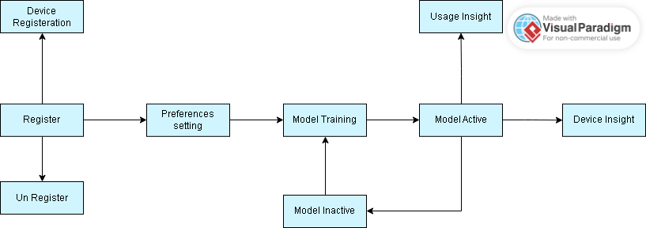
Figure 1: Box and line diagram
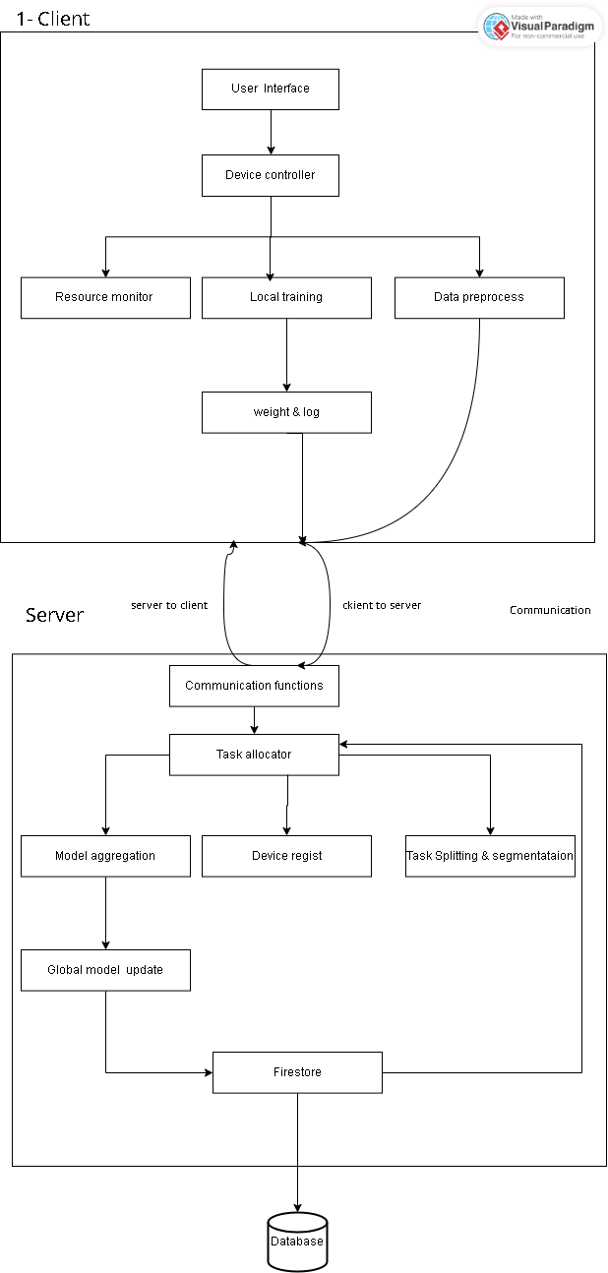
Figure 2: Architecture diagram

Design Models
The design methodology for the project “Fractal” is Object oriented programming methodology. OOP supports core of its concepts (polymorphism, encapsulation, polymorphism, modularity) those helps in reducing coupling (minimizing dependencies between entities) and high coupling entity focus on single responsibility. The Fractal project most of the functionalities are performed without user involvement. Due to this reason, the requirement identification technique used for the Decentralized distributed computation harvesting system is the Event response table. So instead of use-cases for diagrams we are according to each event and system response

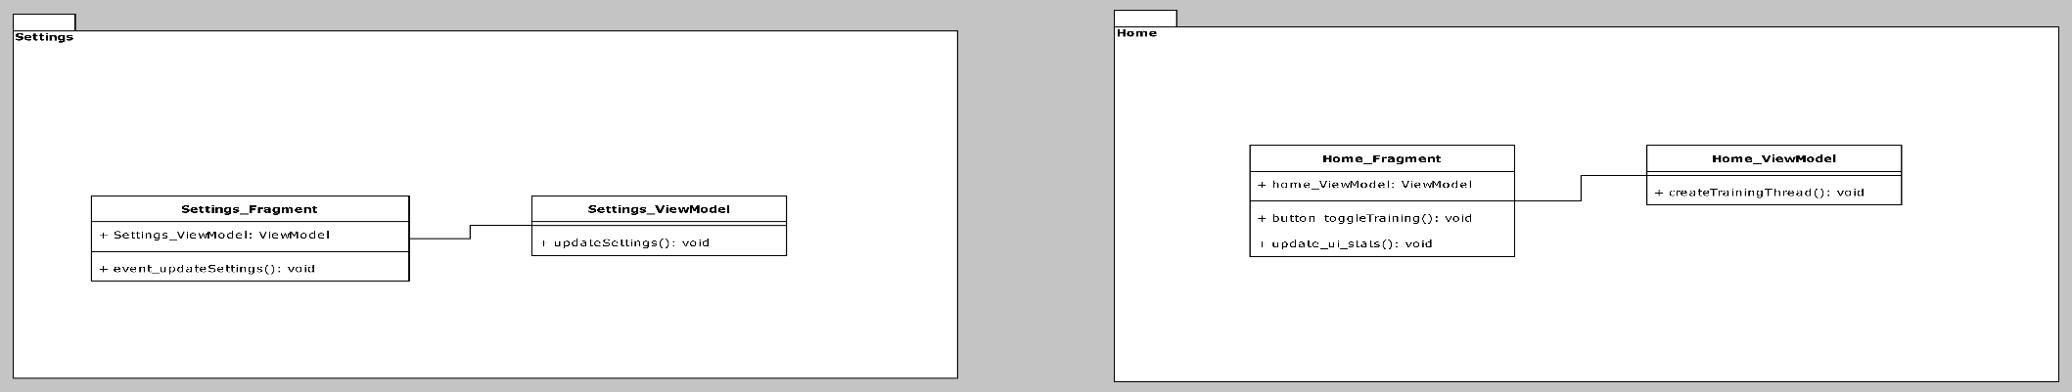
Class Diagram (for whole system):
Figure 3 APP Interface 1

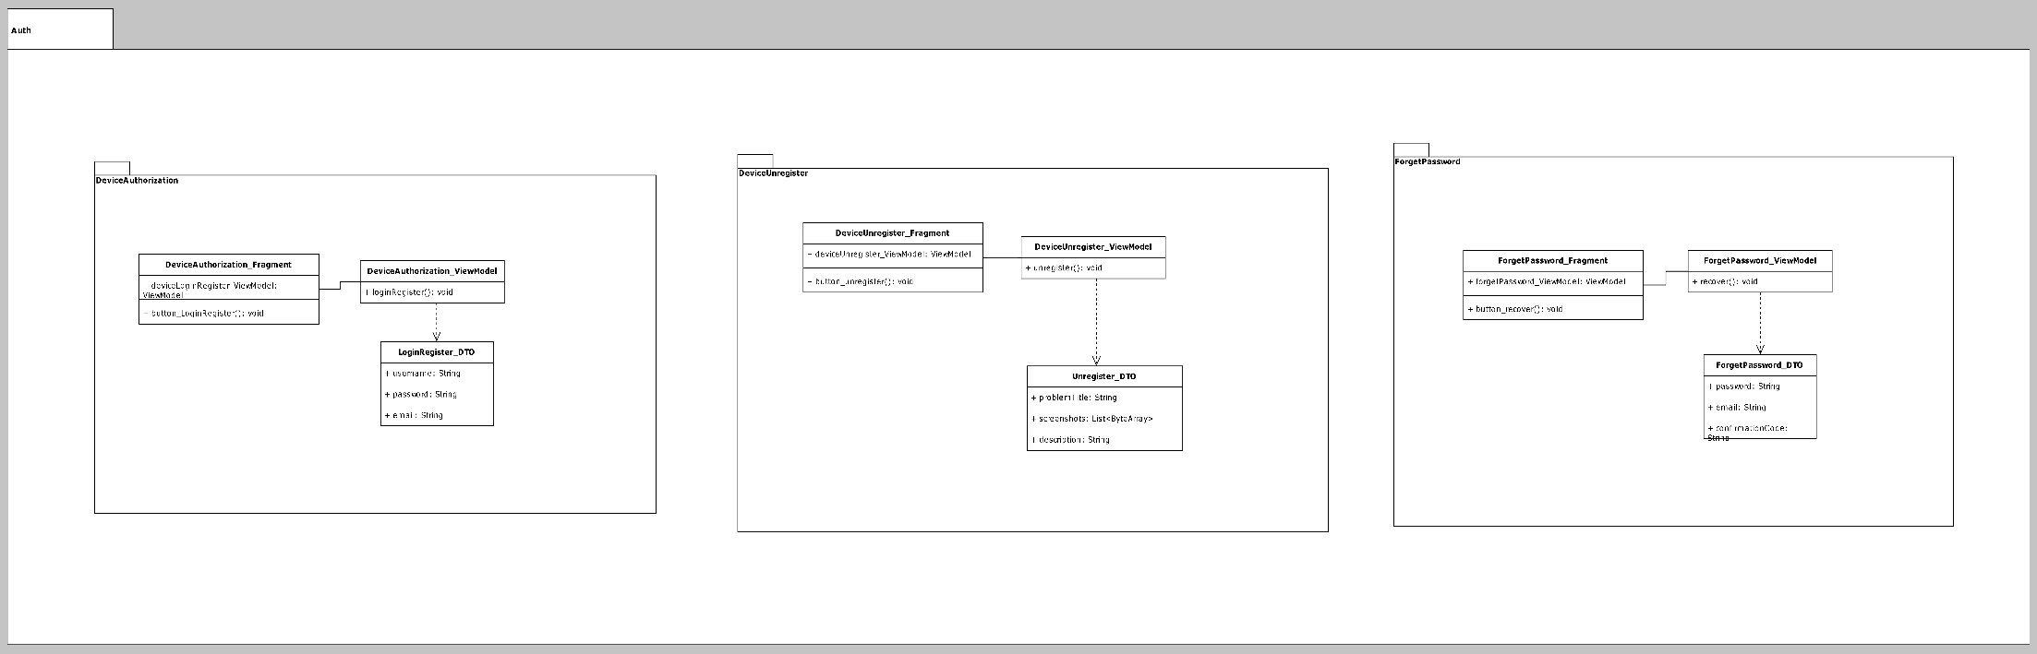
Figure 4 APP Interface 2
Figure 5 - APP Interface part3
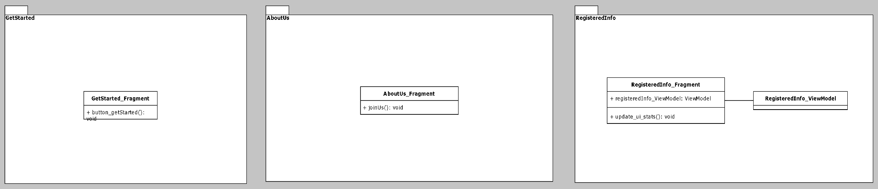
Figure 6 APP Interface 3
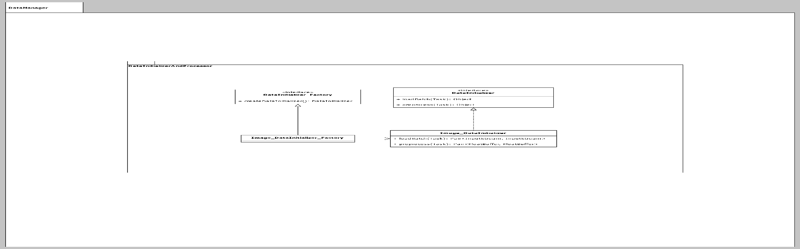
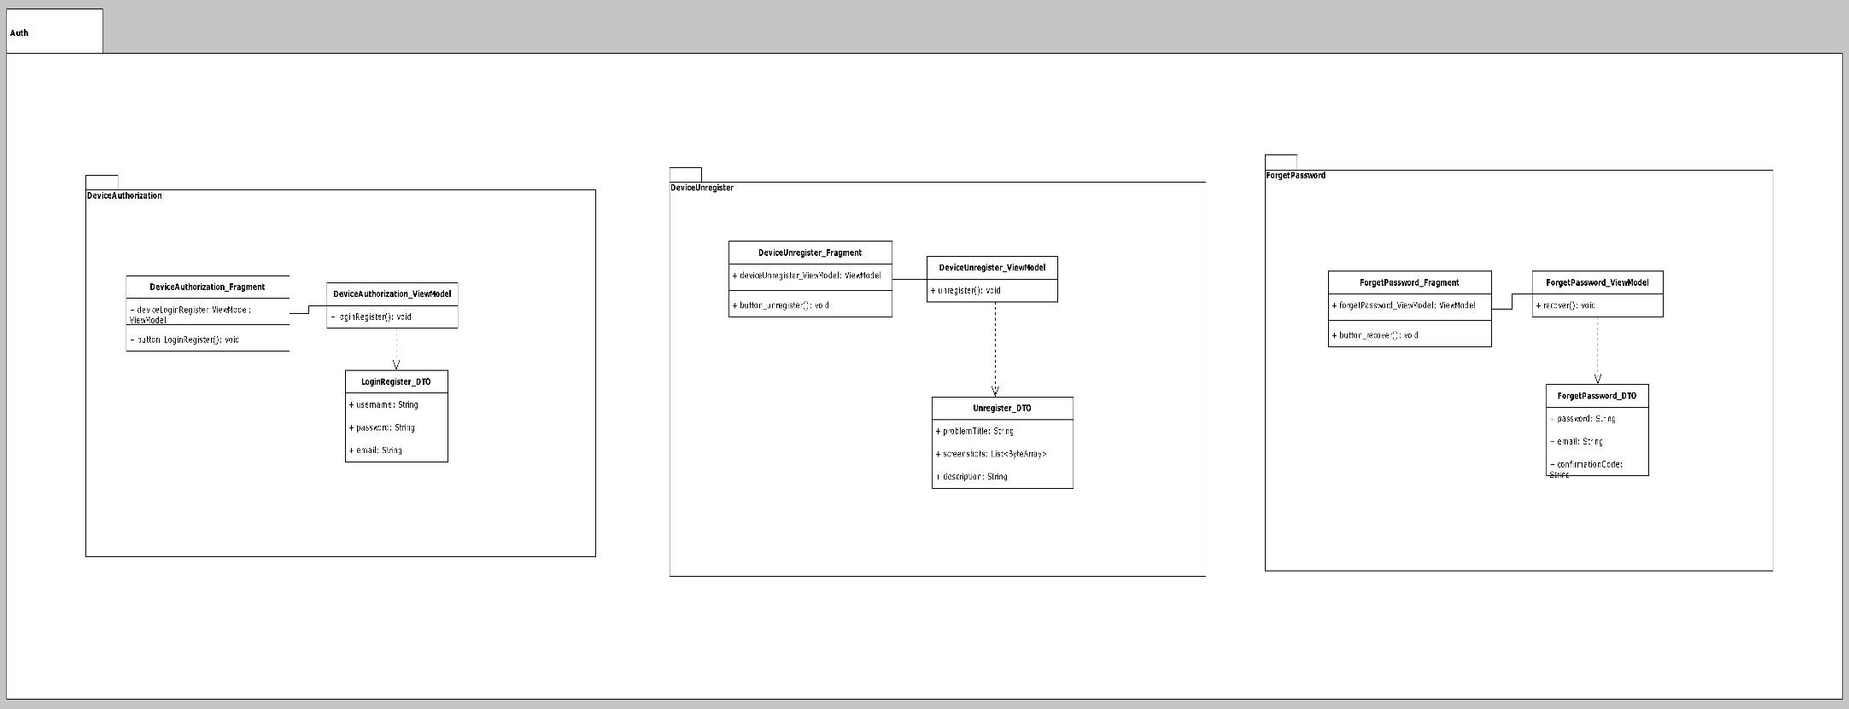
Figure 7 APP Interface 5
Figure 8 APP Interface 4
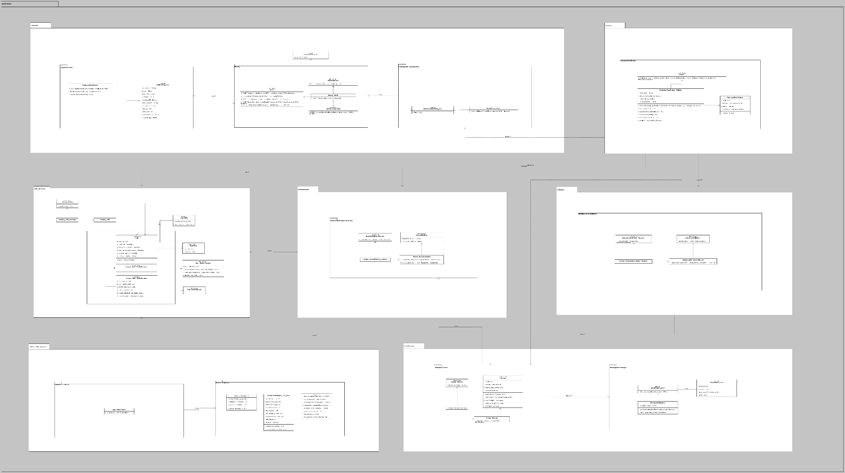
Figure 9 APP Interface complete
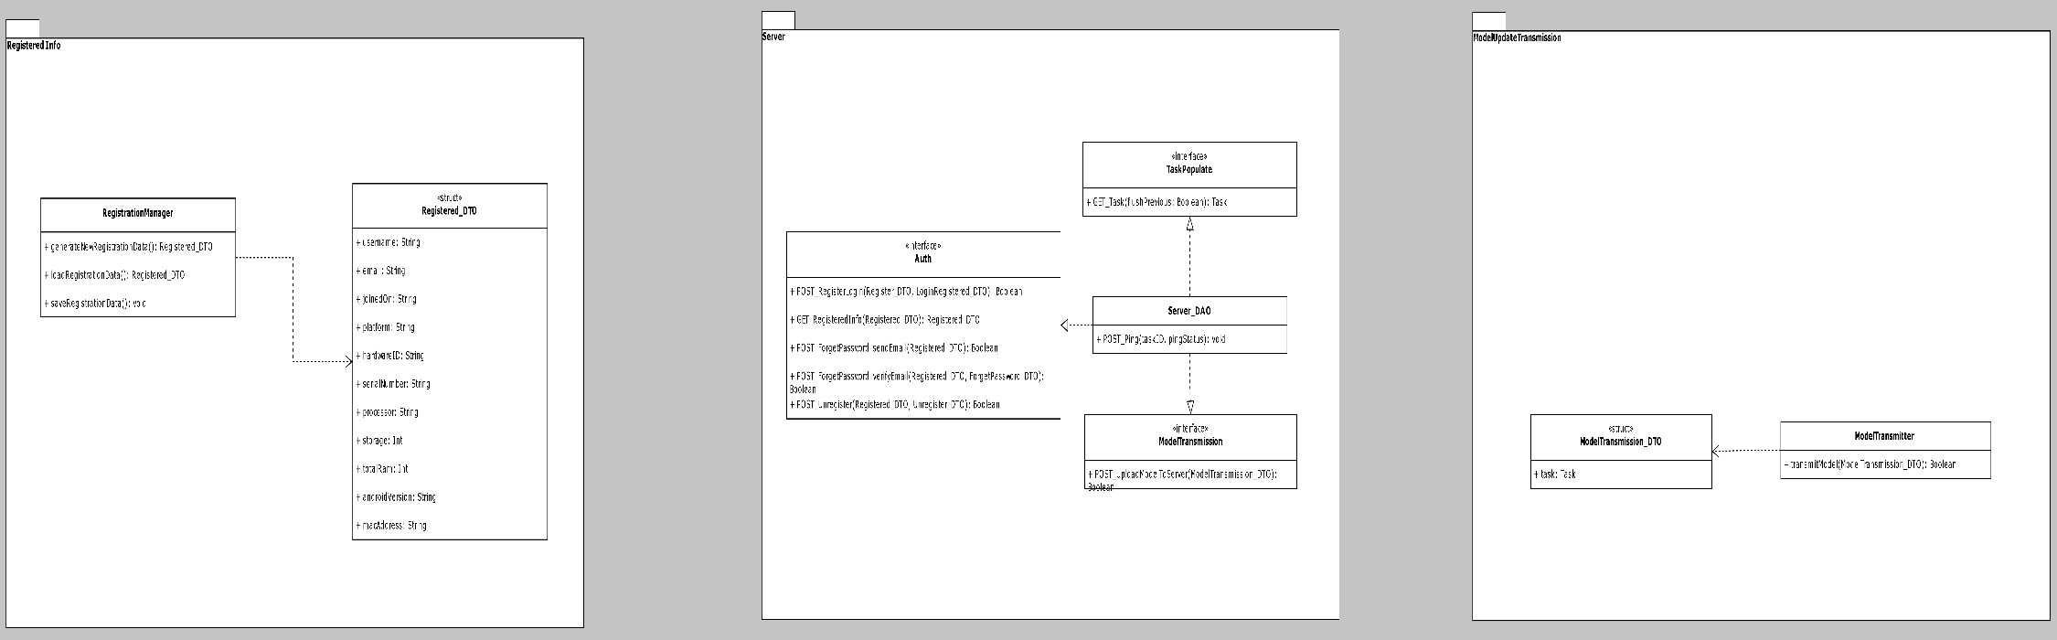
Figure 10 APP Interface
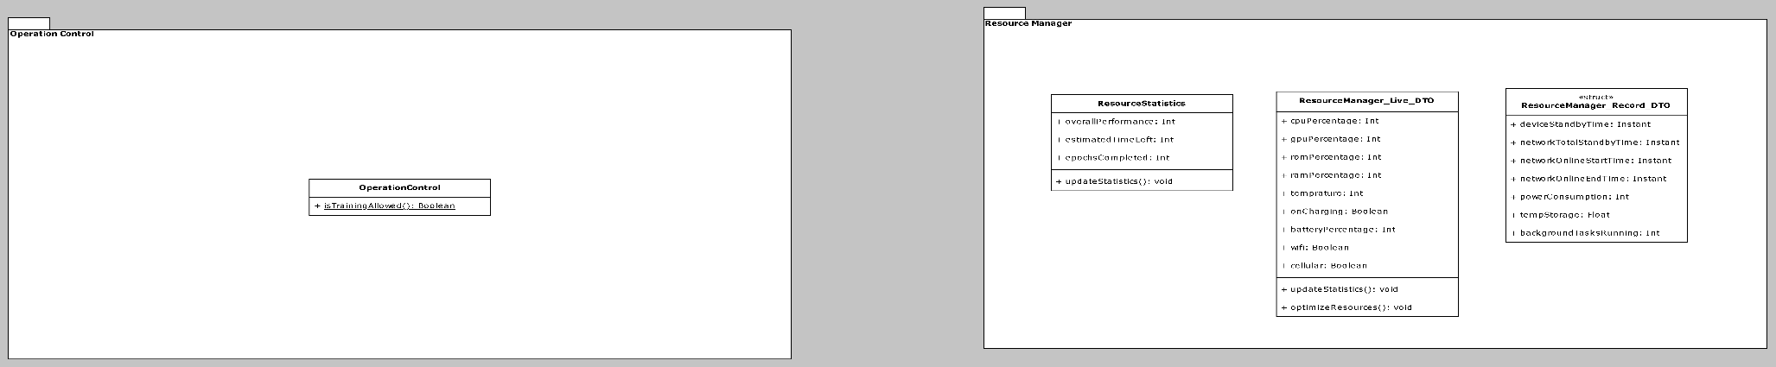
Figure 11 resource management

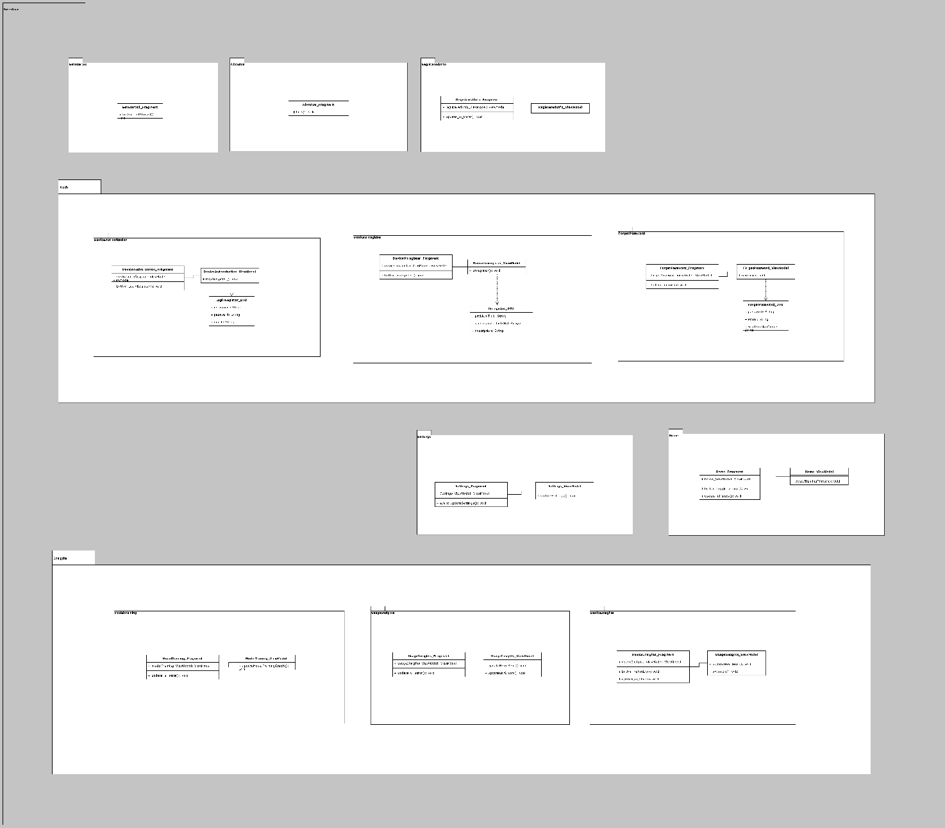
Figure 12 Interface
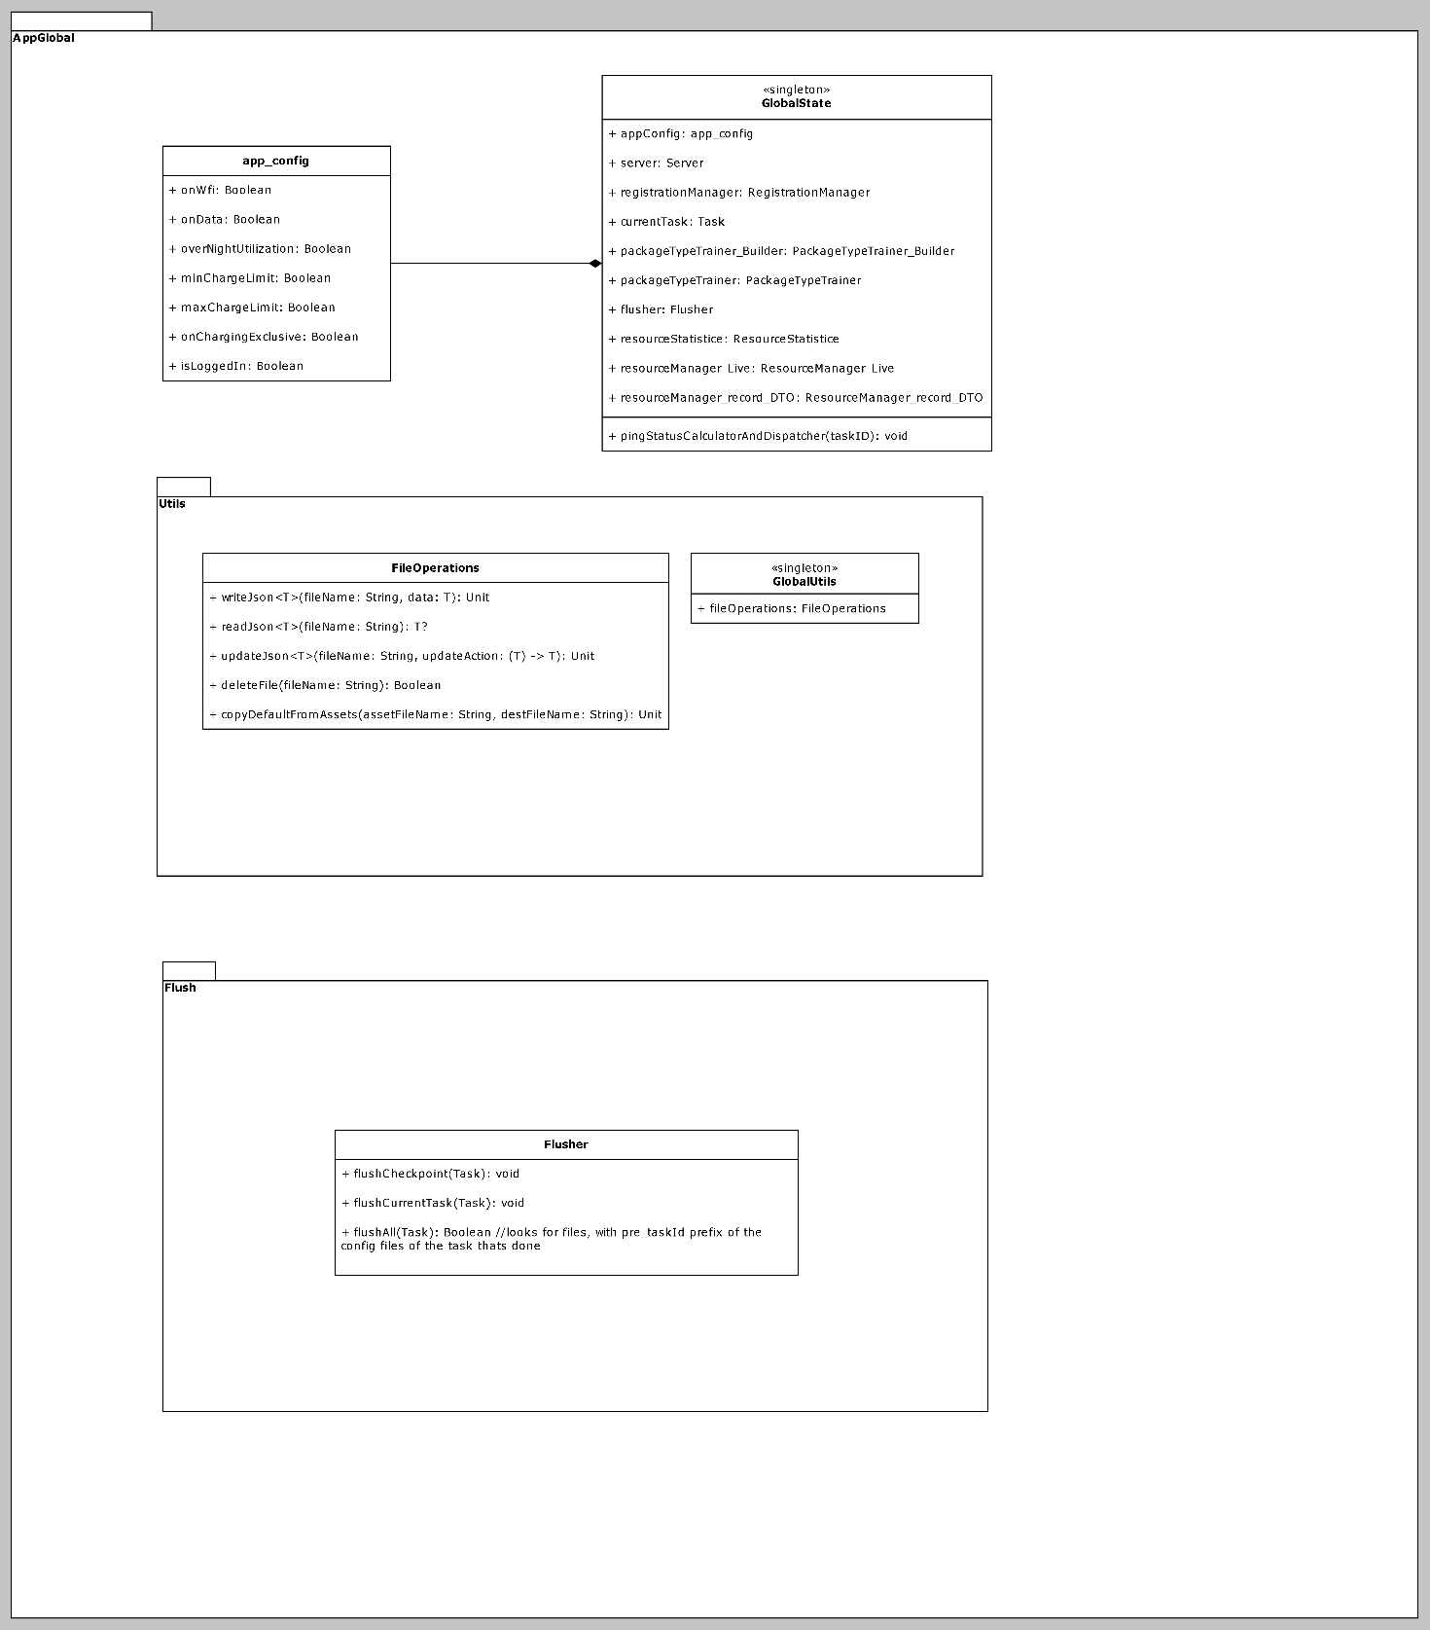
Figure 13 App Global

In this system most of the functionalities are performed without user involvement. Due to this reason, the requirement identification technique used for the Decentralized distributed computation harvesting system is the Event response table. The Event response table for the system is provided below:

Event | System State | System Response
The user signs up, powers on the device, and connects to a network | The device is not registered | The device registered with the server using stats like ID, RAM, battery, etc.
The server sends a ping to the device | The device is currently online | Respond to server ping with the status
Device available resources | The device is ready for training | Send task request
Task assigned | The device is idle | The device receives data, preprocess it, and formats it for training
Data has been preprocessed and is available | The device is idle and ready for training | With TensorFlow Lite/ PyTorch Mobile, start local training and continuously monitor performance
Local training complete | Waiting for the transfer weights to the server | Transmit weights and biases to the server
Receive weight and biases from other devices | Model aggregation is in waiting | Save weight, aggregate, and then update the global model
Global model updated | The device is idle or available for the new task | Redistribute the model to available devices
New training job for the task queue | Device available | Check devices in the database, and their resources, and allocate tasks
Task failed | Timeout | Recheck devices in the database, their resources, and allocate tasks
Device offline | Task incomplete | Task failed and reassign the task to another device
Task assigned to all available | All devices are updated | Save logs in a database, and continuously monitor contributions
Device low battery | The task is in running | Pause training, reassign the task to another device
Table 28 Event response table

ER-1 Activity Diagram:
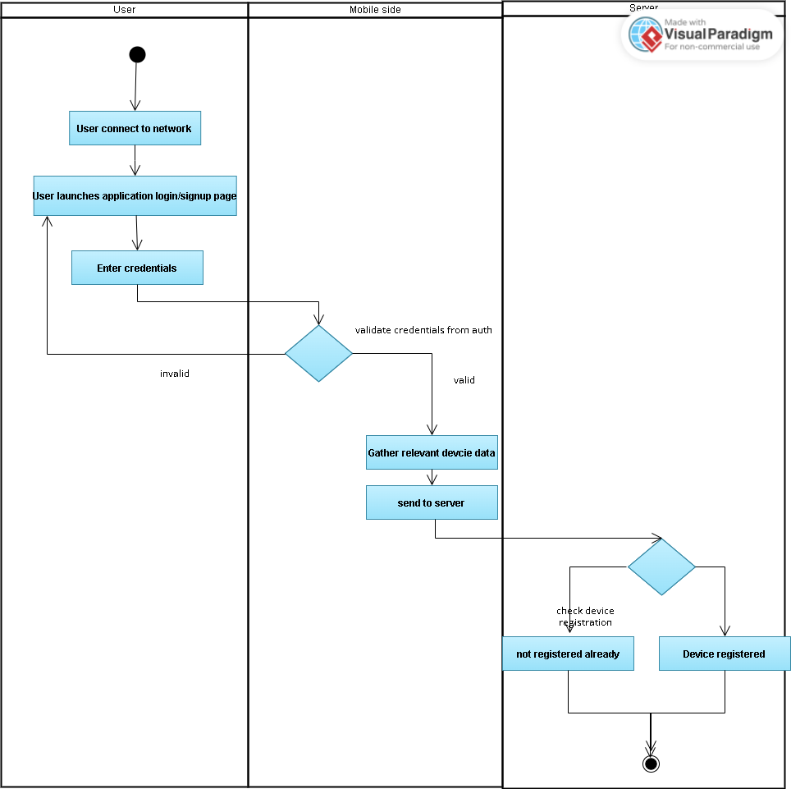
Figure 14- ER1-Activity diagram

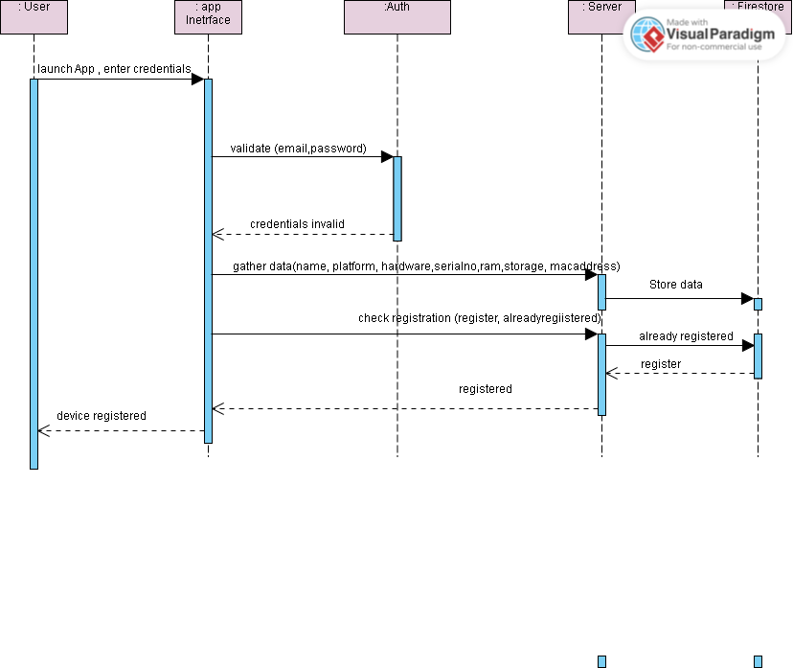
ER-1 System Sequence diagram:
Figure 15-ER1 system sequence diagram

ER-1 State transition diagram:

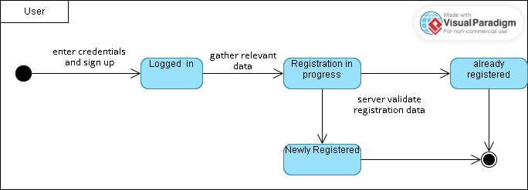
Figure 16-ER1 State transition diagram

ER-2 Activity diagram:
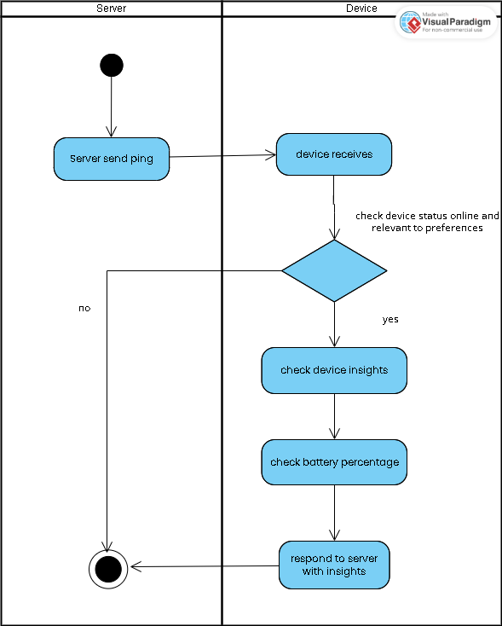
Figure 17- ER2 Activity diagram

ER-2 System Sequence diagram:

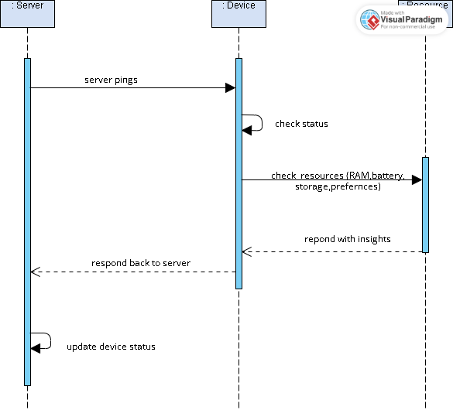
Figure 18 - ER2 System sequence diagram

ER-2 State transition diagram:

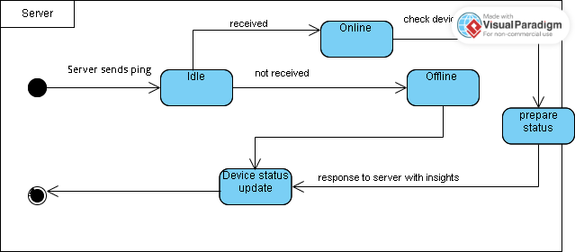
Figure 19 -ER2 State machine diagram

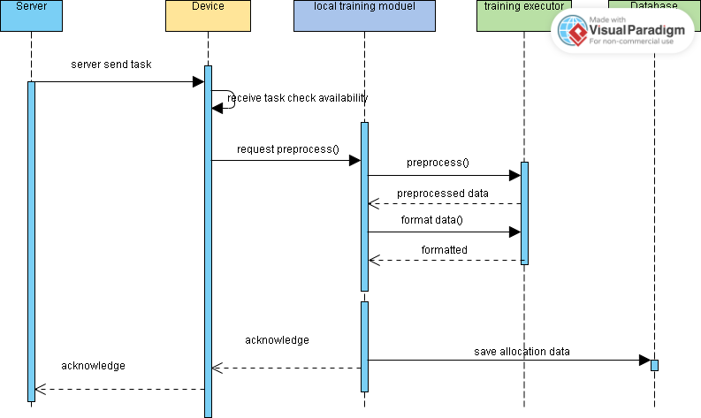
ER-3 Sequence diagram
Figure 20 - ER3 Sequence diagram

ER-3 Activity diagram:
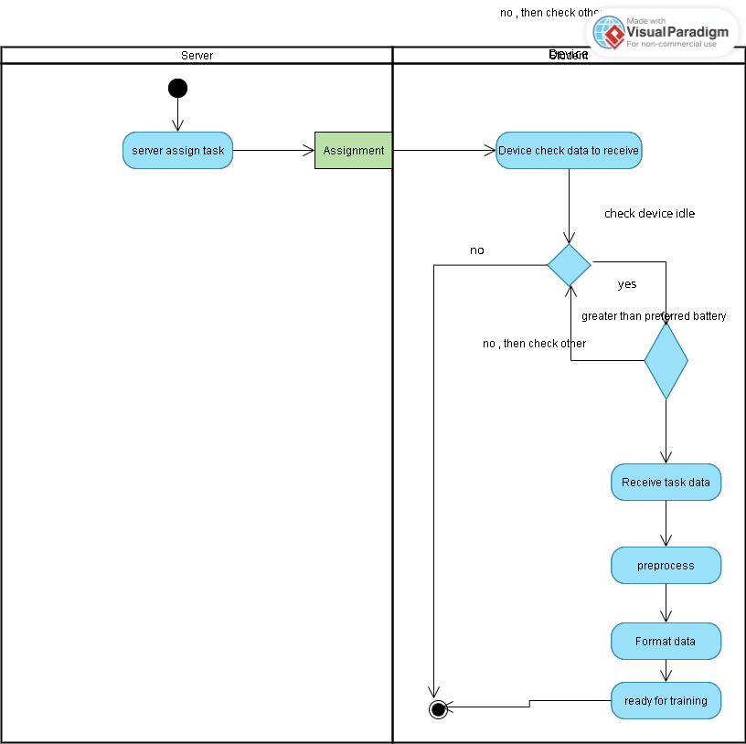
Figure 21 - ER3 Activity diagram

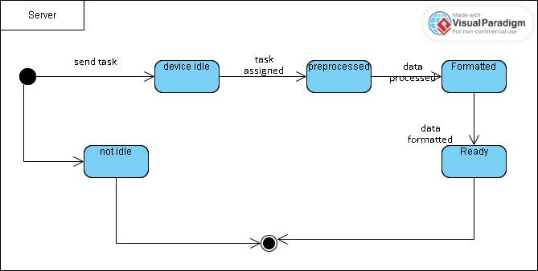
ER-3 State machine:
Figure 22 - ER3 State machine diagram

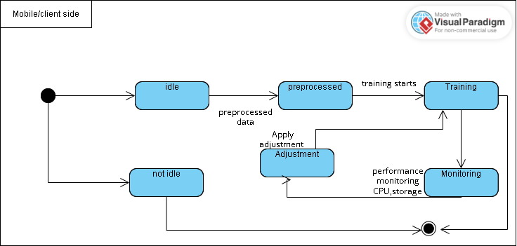
ER-4 State machine:
Figure 23- ER4 State machine diagram

ER-4 Activity Diagram:

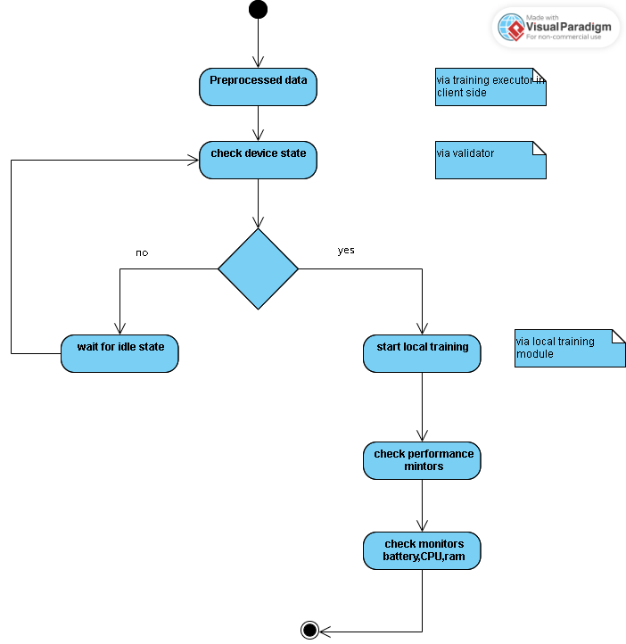
Figure 24- ER4 Activity diagram
ER-4 System Sequence:
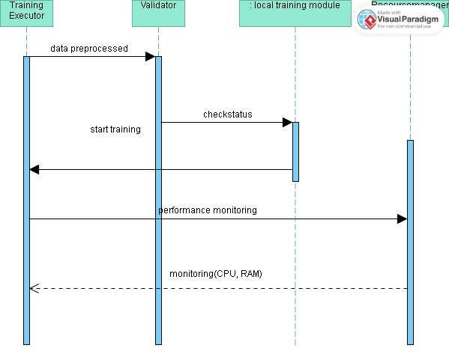
Figure 25- ER4 System sequence diagram

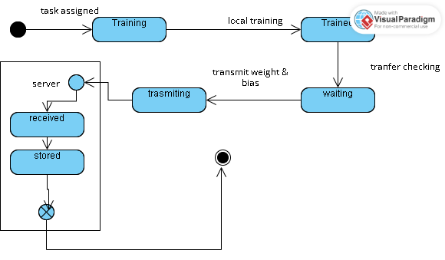
ER-5 State machine Diagram:
Figure 26- ER5 State machine diagram
ER-5 Activity Diagram:
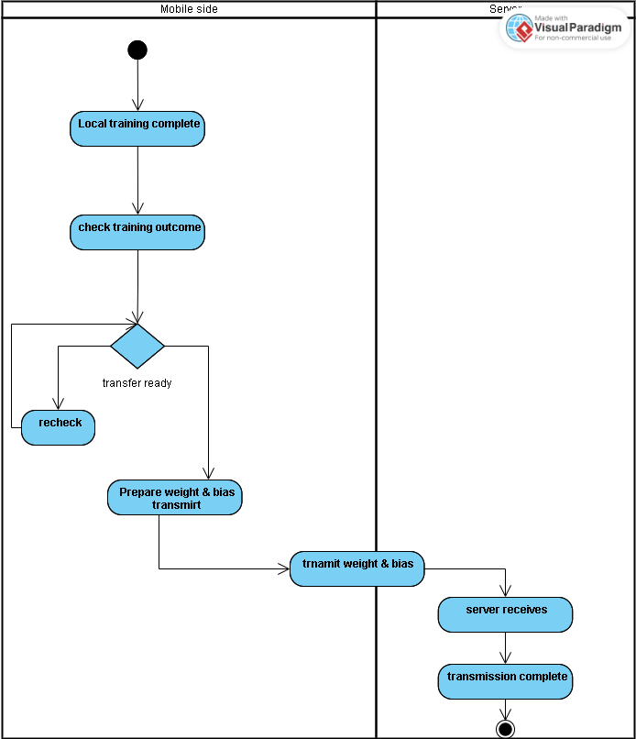
Figure 27- ER5 Activity diagram

ER-5 System Sequence diagram:

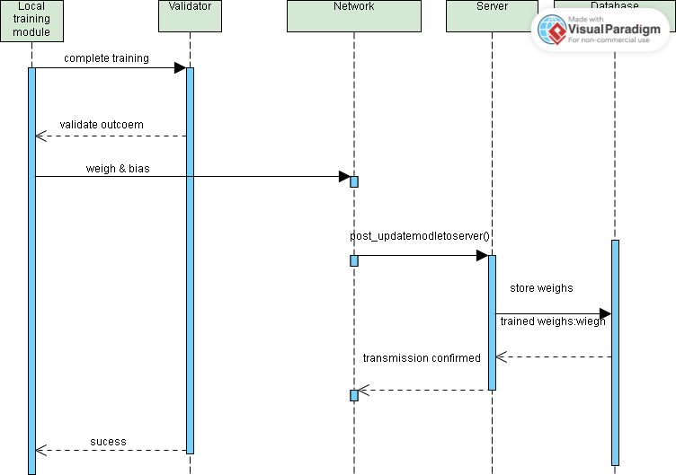
Figure 28- ER5 System sequence diagram

ER-6 Activity diagram:

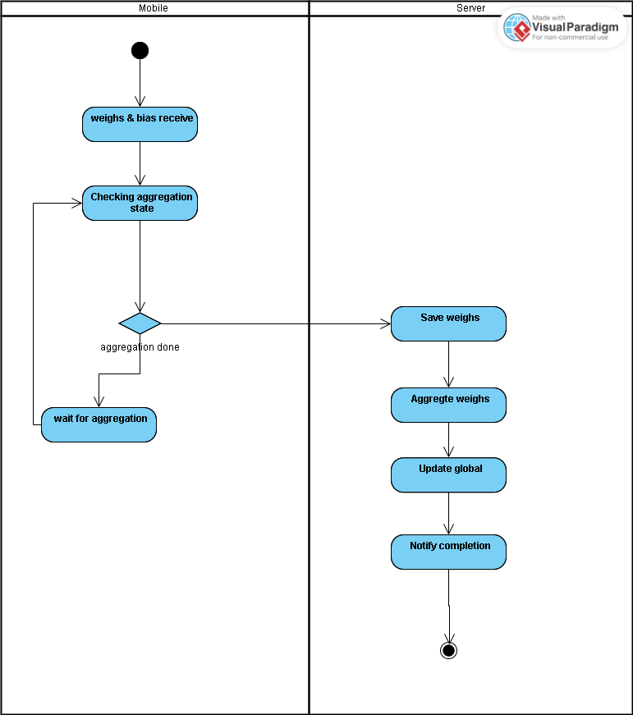
Figure 29- ER6 Activity diagram

ER-6 Sequence diagram:

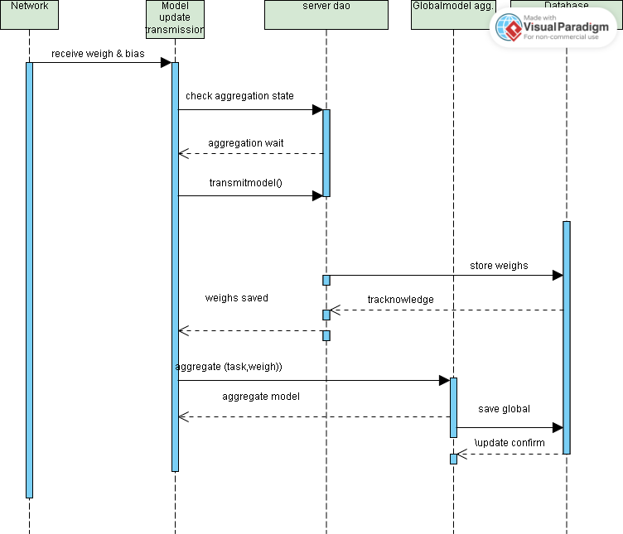
Figure 30- ER6 System sequence diagram

ER-7 Activity diagram:
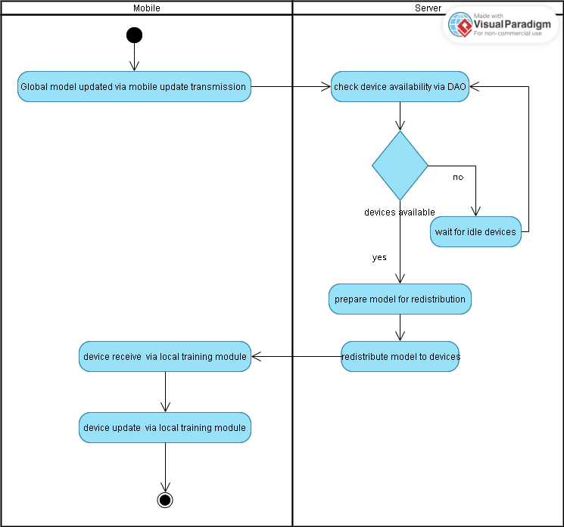
Figure 31- ER7 Activity diagram

ER-7 Sequence diagram:

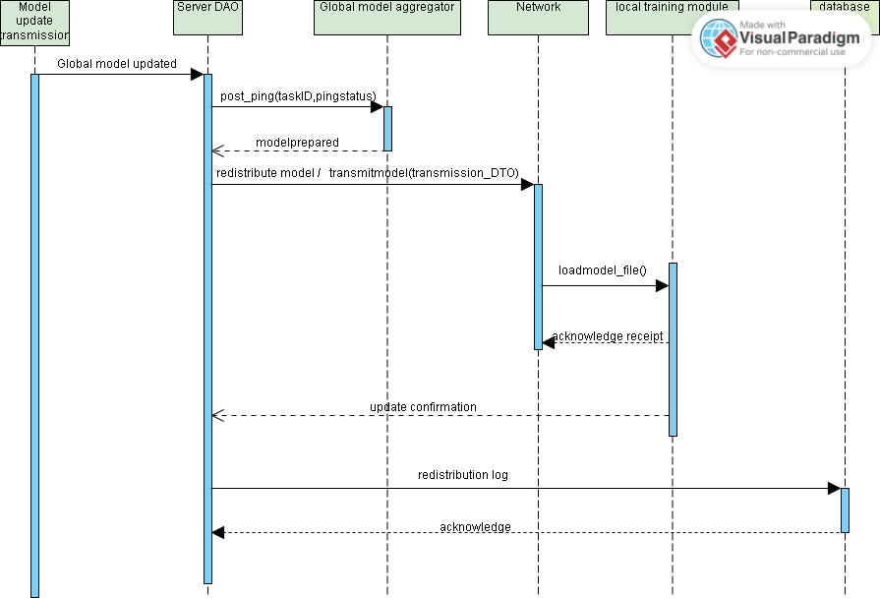
Figure 32- ER7 Sequence diagram

ER-7 State machine diagram:
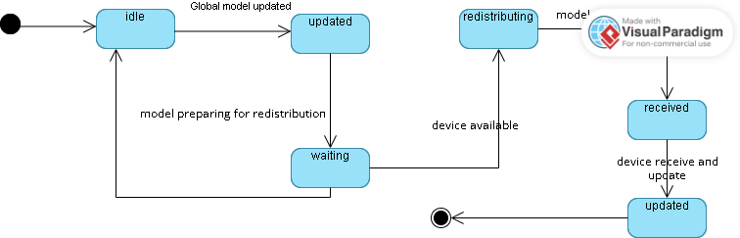
Figure 33- ER7 State machine diagram

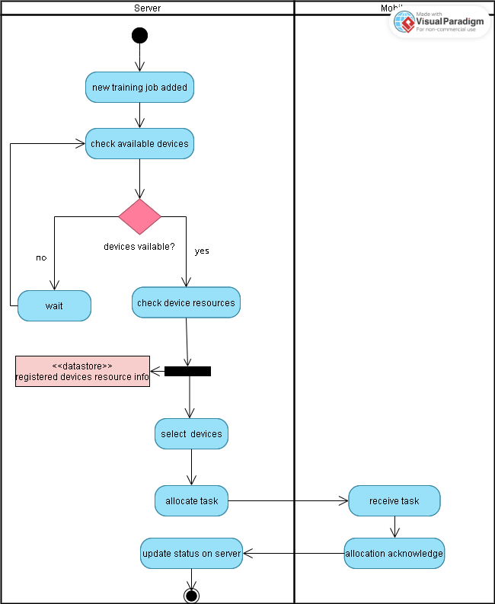
ER-8 Activity diagram:
Figure 34- ER8 Activity diagram
ER-8 Sequence diagram:
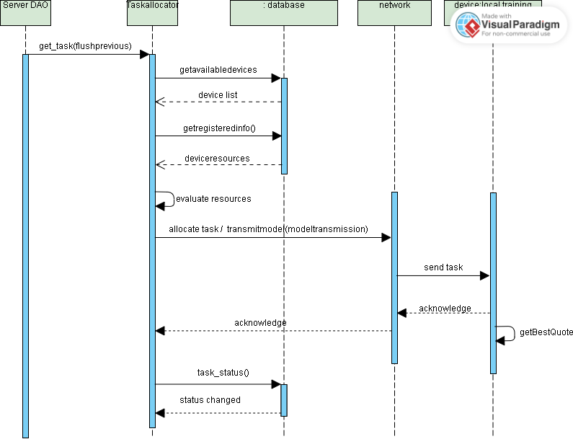
Figure 35- ER8 Sequence diagram
ER-8 State machine diagram:
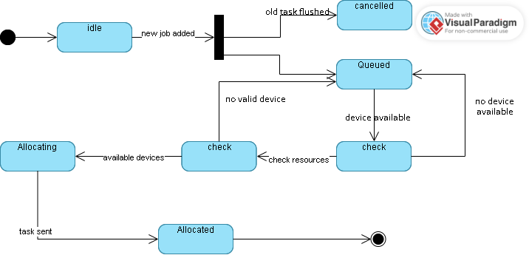

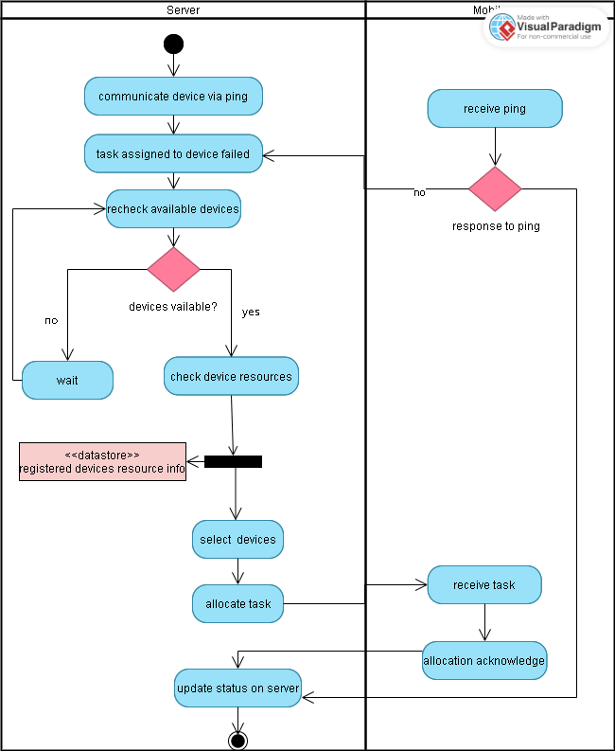
ER-9 Activity diagram:
Figure 36- ER9 Activity diagram

ER-9 Sequence diagram:

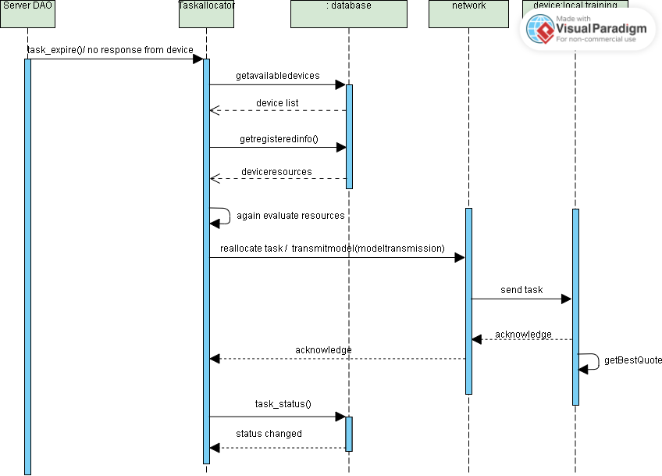

Figure 37- ER9 System sequence diagram

ER-9 State machine diagram:

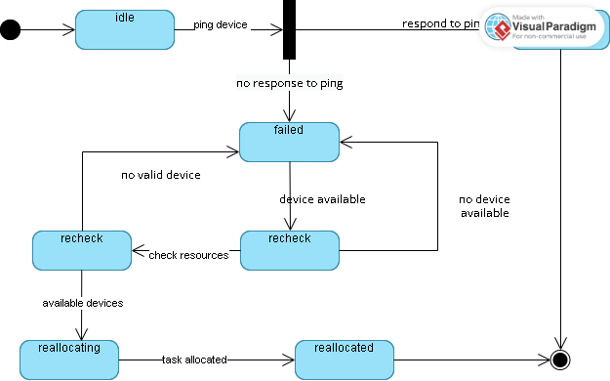

Figure 38- ER9 State machine diagram

ER-10 Activity diagram:
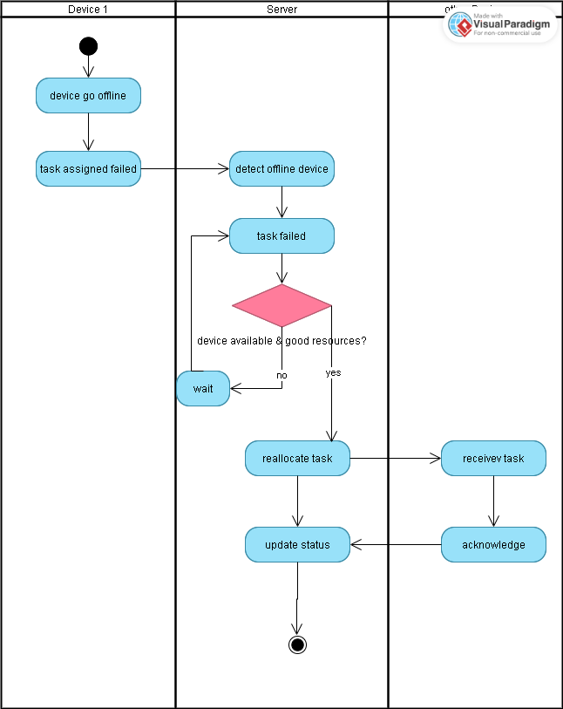
Figure 39- ER10 Activity diagram
ER-10 Sequence diagram:

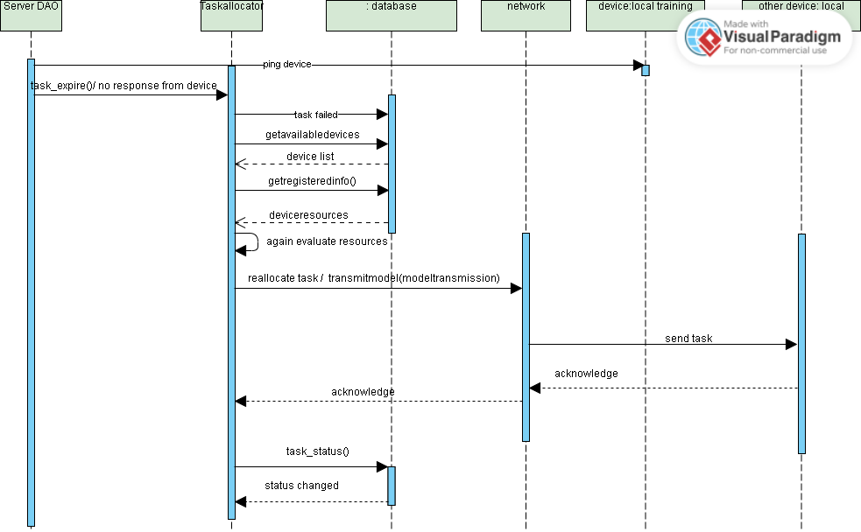
ER-10 State machine diagram:
Figure 40- ER10 System sequence diagram
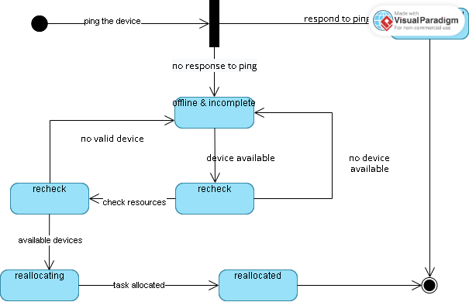
Figure 41- ER10 State machine diagram
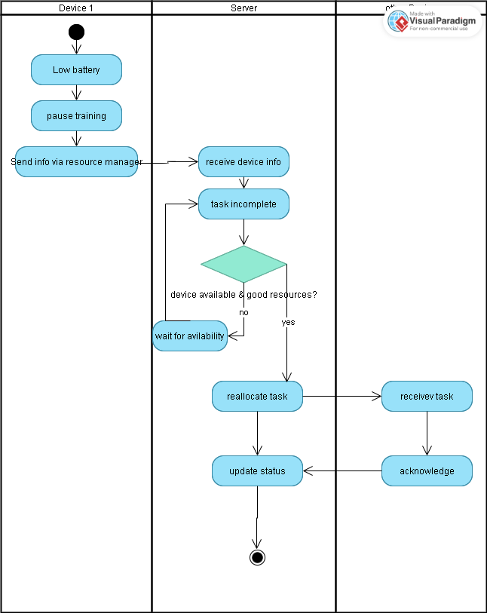
ER-11 Activity diagram:
Figure 42- ER11 Activity diagram
ER-11 Sequence diagram:
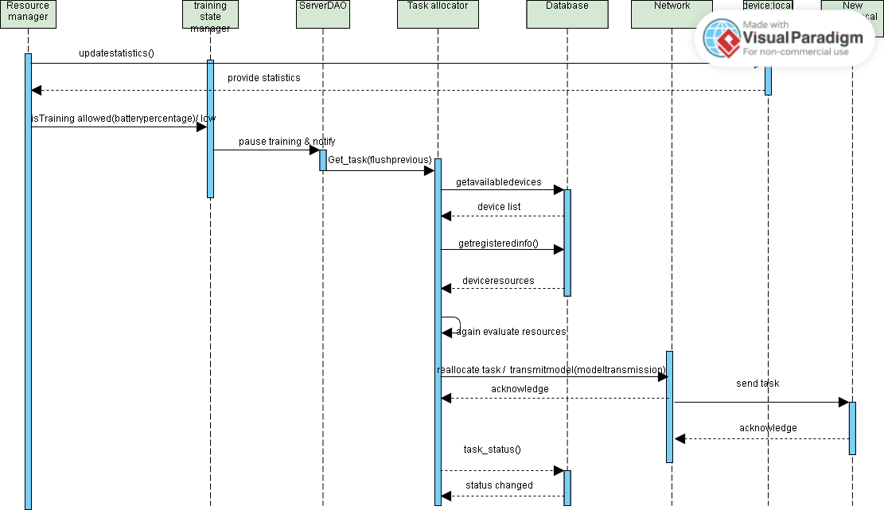

Figure 43- ER11 Sequence diagram
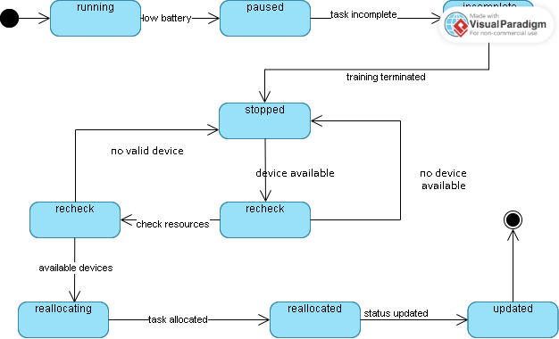
ER-11 State machine diagram:
Figure 44- ER11 State machine diagram

Data Design
The information domain of the Fractal system is transformed into data structures into four major entities User, task, Allocation record, Unregister DTO. User registration is stored in User collection. User un-registration complaint and description request data from Unregister DTO collection. When tasks are assigned to user, task assignment information is stored in task allocation collection. Training tasks are stored by type and date. Database used is Firebase Fire store NoSQL

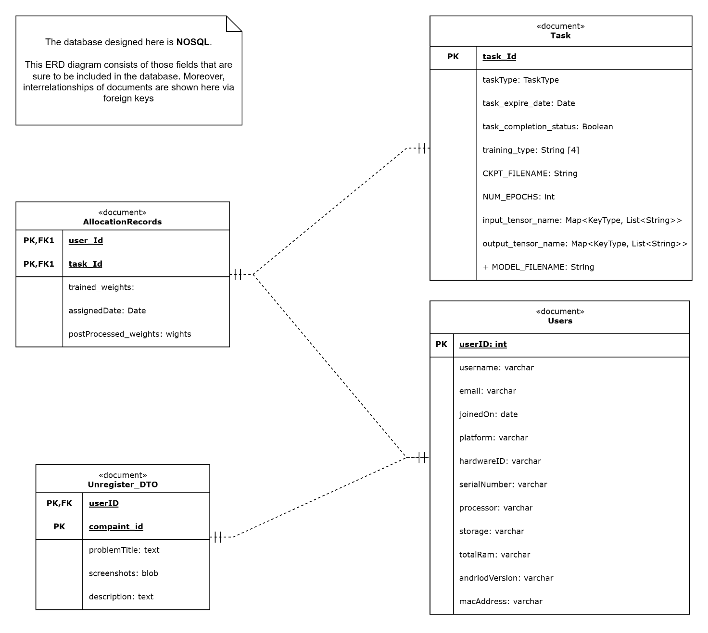
Figure 45- ERD diagram

Data Dictionary
Data dictionary list system entities with its attributes, methods and method parameters. All are provided below:

- Allocation Records:
Attributes:
- User ID
- Task ID
- Trained weight
- Assigned weight
- Post processed weight

- Task
- Task type
- Task id
- Tasks expire date
- Task completion status
- Training type
- Input tensor name
- Output tensor name
- CKPT-filename
- User
- User ID
- Username
- Email
- Joined on
- Platform
- Hardware ID
- processor
- Storage
- Total RAM
- android version
- macAddress
- Unregister-DTO
- Complaint ID
- User ID
- Problem title
- Screen shot
- Description

Human Interface Design
Fractal (a decentralized distributed computation harvesting to provide computation services) is a system that allows users to join the computation harvesting network by installing the application, then by sharing the idle resources of their devices (android mobile devices as contributor’s only) for tasks such as model training. Below provided screen images are the step-by-step guide of using system from user’s perspectives

4.4.4 Screen Images
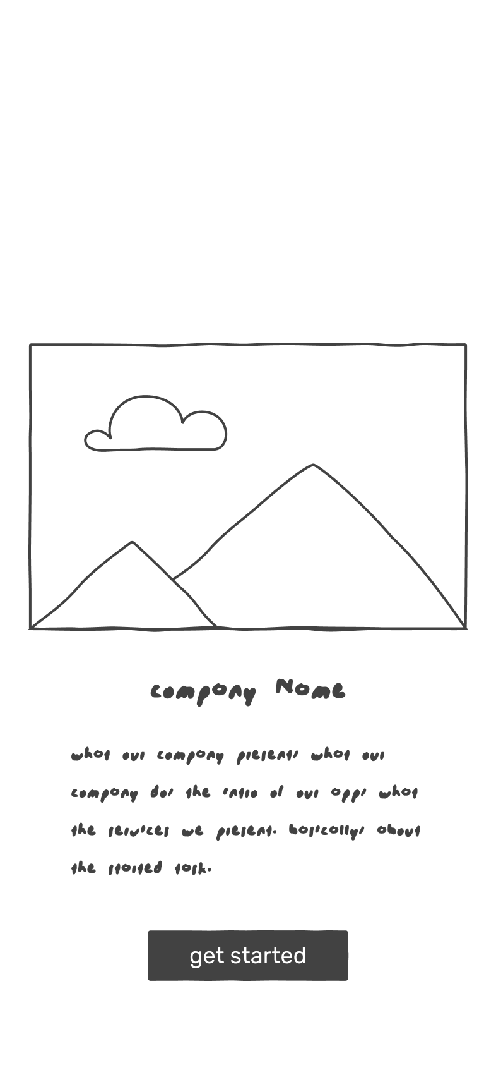  Figure 46-Home |  | 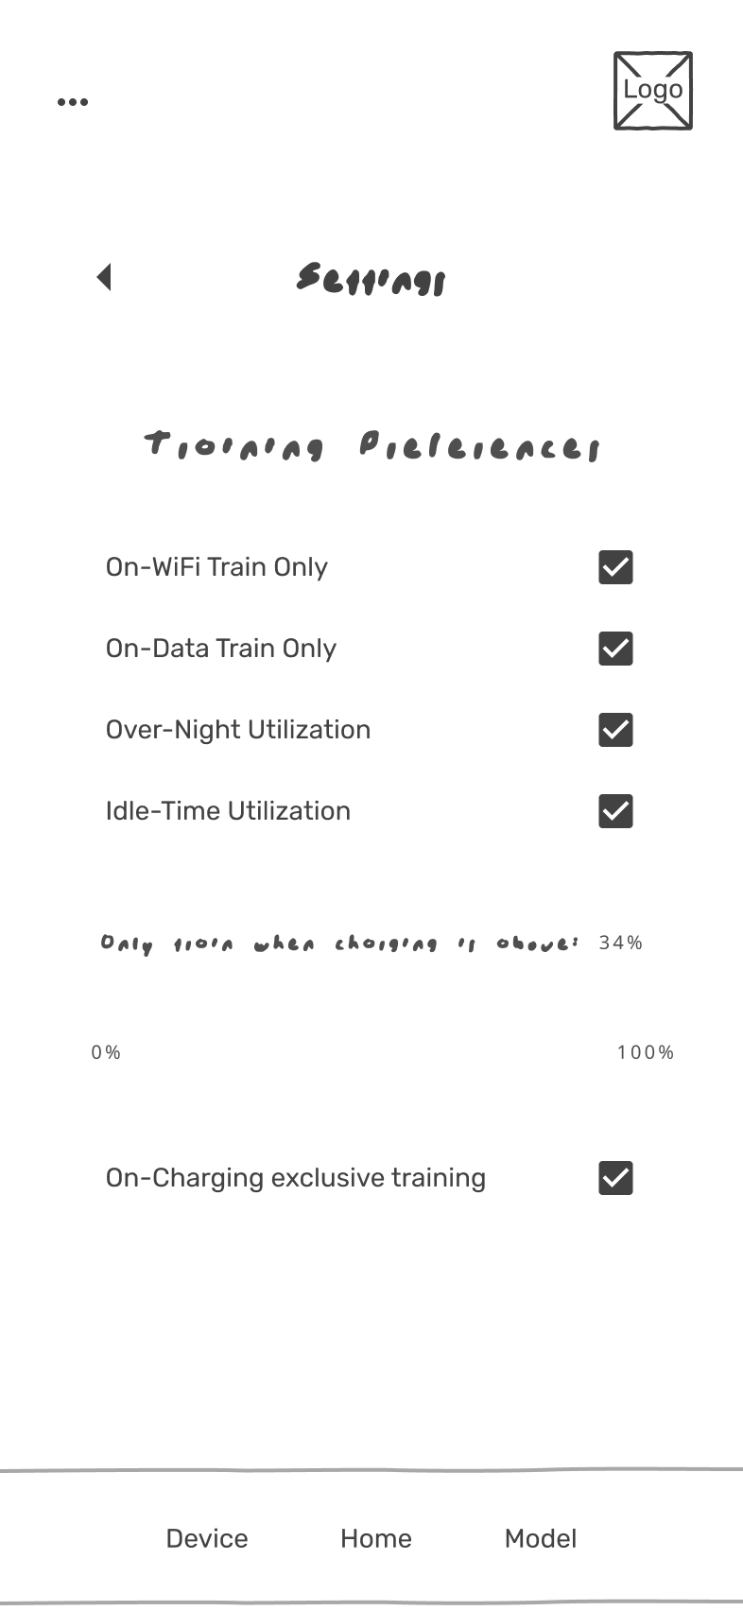  Figure 47-Setting
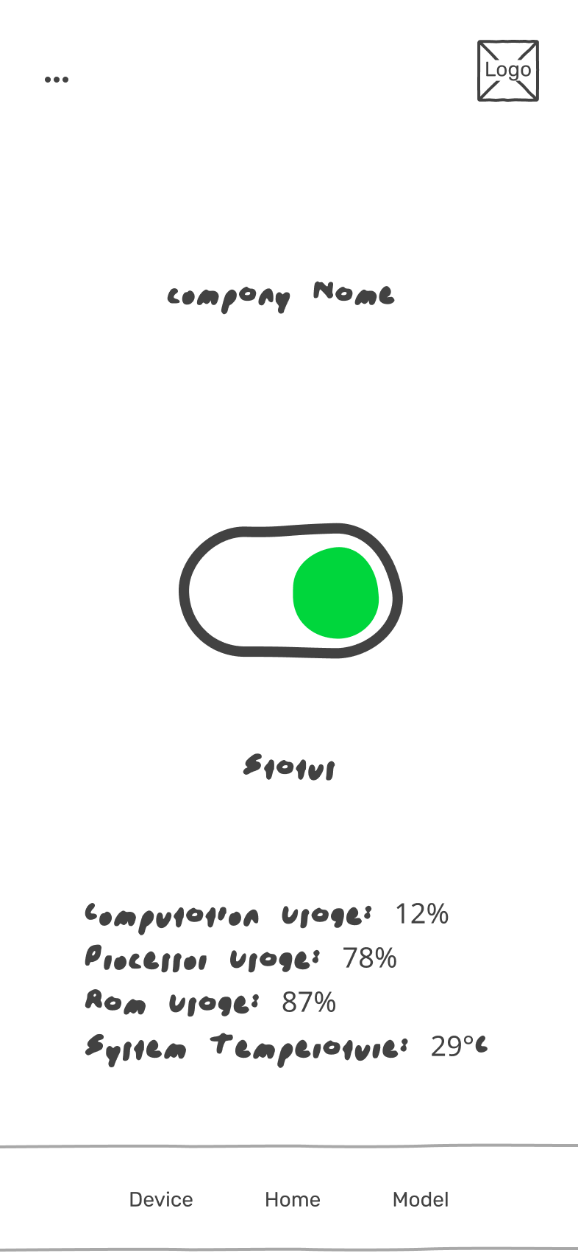  Figure 48-Active | 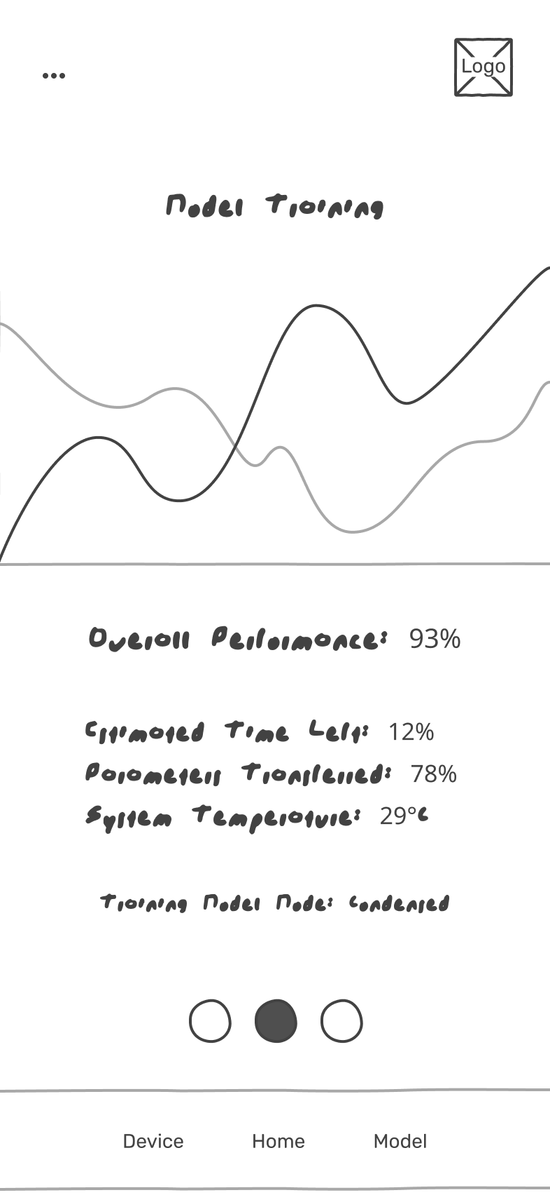  Figure 49 - Model training
Figure 50-Device insight screen  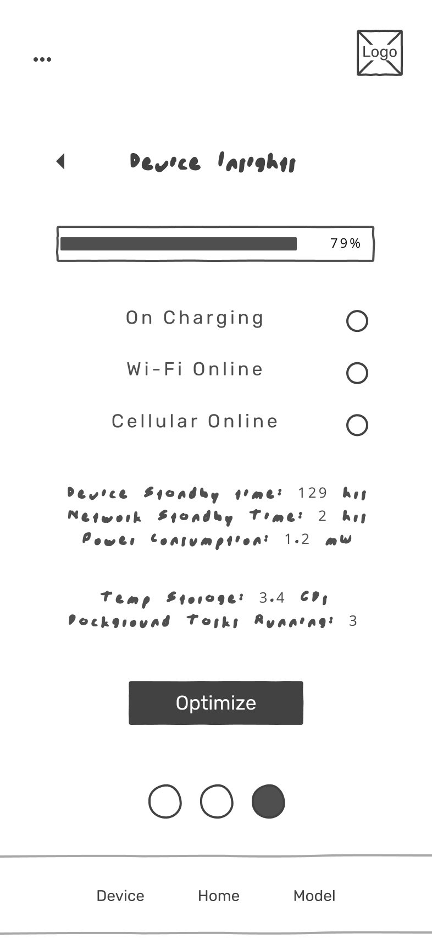 | Figure 51 - Usage insight screen  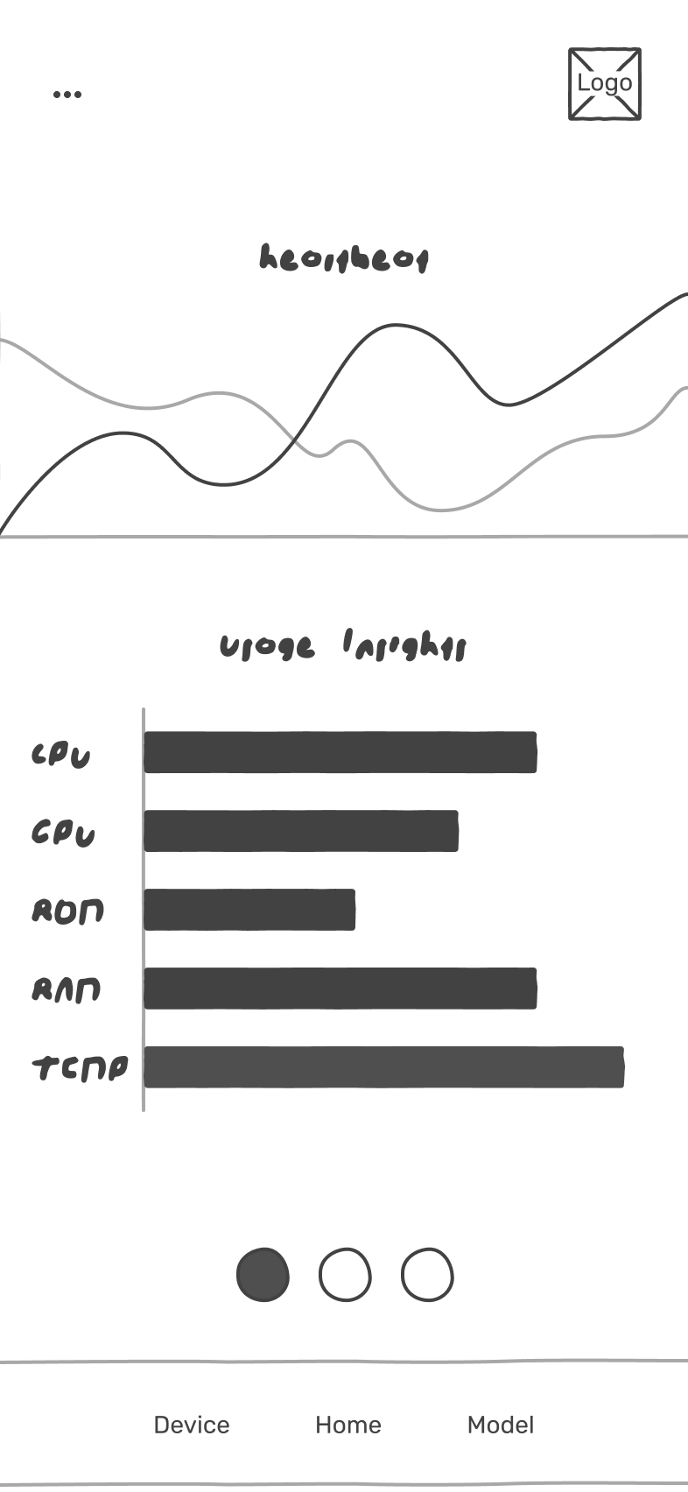

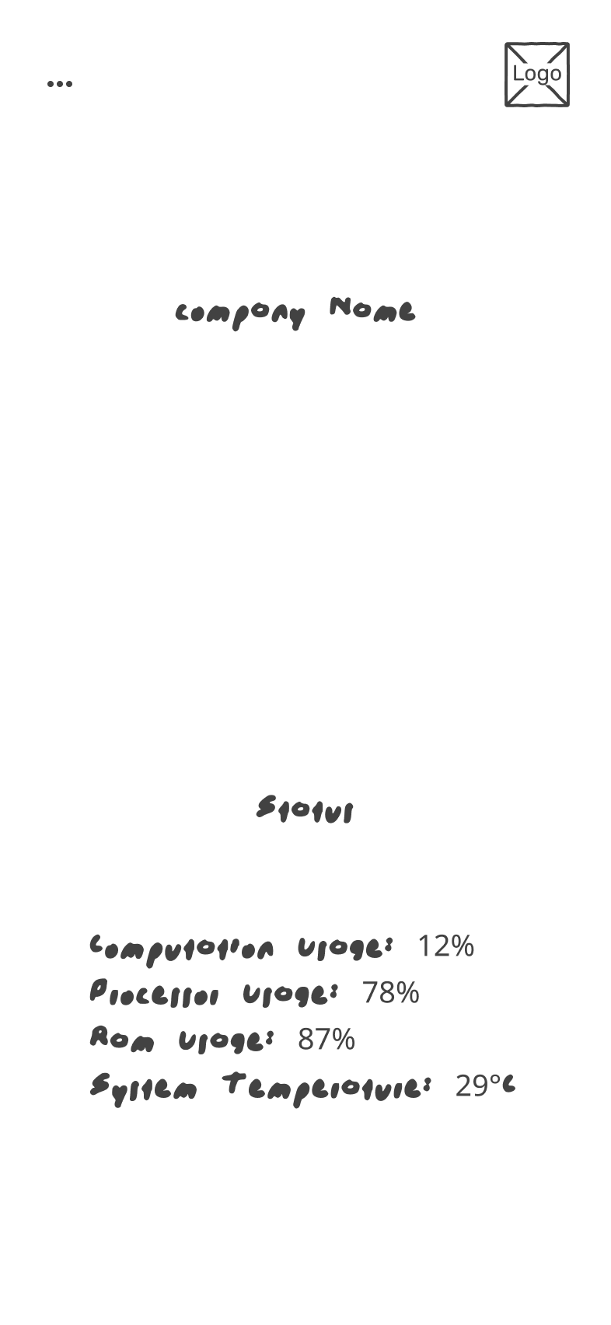Figure 52 - Status screen | 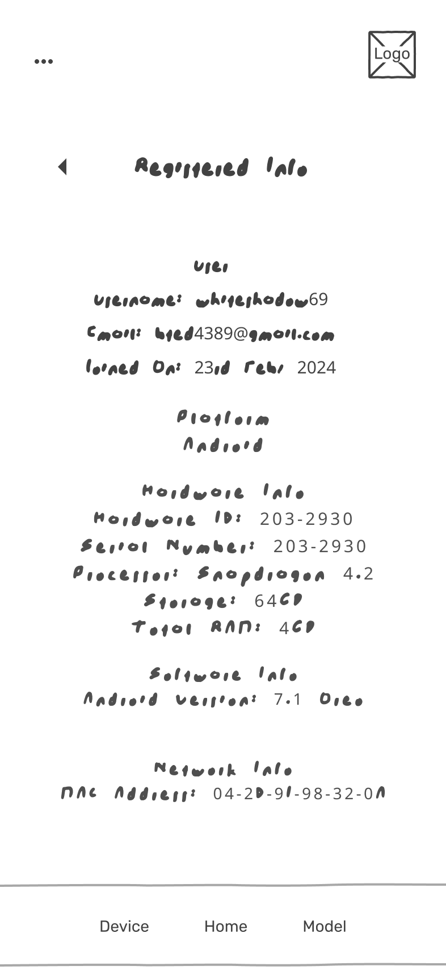  Figure 53 - Registration screen

Screen Objects and Actions

Objects
- Company Name
- Button
- Checkboxes
- Slider
- Botton navigation
- Toggle switch (app)
- Usage insight graph
- Training insight graph

Actions
- Company names display the “Fractal” with additional information below
- Setting checkboxes allows user to select preferences according to choice
- Sliders allow users to select minimum battery level for training
- Optimize button triggers to improve device performance
- Get started button work as a join now link
- Toggle switch is used to active/inactive for training
- Botton navigation bar navigates to selected group of screens
- Second toggle designed navigation bar navigates to the screen of device insight and usage insight
- Training insight graph displays the progress of the model training over the time
- Usage insight graph displays the resource consumption

Implementation
This section lists the user interface and all the algorithms that combine to make the system work. These algorithms are provided in the structured pseudocode from

Algorithm
Below are the core functional modules of this class described with clear structured pseudocode
Algorithm 1 Model initialization
Input: Android context
Output: Initialize tensor flow lite interpreter
1: FUNCTION InitializeModel(context)
2: TRY
3: Open asset file descriptor for "model.tflite"
4: Map model file to read-only ByteBuffer (modelBuffer) using FileChannel
5: interpreter ← new Interpreter(modelBuffer)
6: LOG "Model loaded successfully"
7: LOG "Available signatures: " + interpreter.signatureKeys
8: CATCH exception
9: LOG "ERROR: Model loading failed - " + exception.message
10: END TRY
11: END FUNCTION
Algorithm 2 On device training loop
Input: Training callback for progress update
Output: Trained model
1: FUNCTION TrainModel(callback)
2: IF interpreter IS NULL THEN
3: LOG "ERROR: Interpreter not initialized"
4: RETURN
5: END IF
6: imgFile ← File(internalStorage, "train_images_server.bin")
7: lblFile ← File(internalStorage, "train_labels_server.bin")
8: IF NOT (imgFile.exists AND lblFile.exists) THEN
9: LOG "ERROR: Training data files missing"
10: callback.onLog("Data files not found")
11: RETURN
12: END IF
13: totalBatches ← NUM_EPOCHS × (NUM_TRAININGS / BATCH_SIZE)
14: currentBatch ← 0
15: merge ← true
16: WHILE merge == true DO
17: merge ← false
18: FOR epoch FROM 0 TO NUM_EPOCHS-1 DO
19: LOG "Starting Epoch " + (epoch + 1)
20: FOR batchIndex FROM 0 TO (NUM_TRAININGS / BATCH_SIZE - 1) DO
21: batchData ← LoadBatchFromFile(batchIndex, imgFile, lblFile)
22: IF batchData IS NULL THEN
23: CONTINUE
24: END IF
25: (imageBatch, labelBatch) ← batchData
26: // Prepare batched inputs
27: batchImages ← AllocateDirectBuffer(BATCH_SIZE × IMG_SIZE × 4).asFloatBuffer()
28: batchLabels ← AllocateDirectBuffer(BATCH_SIZE × NUM_CLASSES × 4).asFloatBuffer()
29: batchImages.put(imageBatch.asFloatBuffer())
30: batchLabels.put(labelBatch.asFloatBuffer())
31: batchImages.rewind()
32: batchLabels.rewind()
33: inputs ← Map("x" → batchImages, "y" → batchLabels)
34: lossBuffer ← AllocateDirectBuffer(4).asFloatBuffer()
35: outputs ← Map("loss" → lossBuffer)
36: interpreter.runSignature(inputs, outputs, "train")
37: loss ← lossBuffer.get(0)
38: currentBatch ← currentBatch + 1
39: progress ← (currentBatch × 100) / totalBatches
40: IF currentBatch MOD 10 == 0 OR currentBatch == totalBatches THEN
41: LOG "Batch " + currentBatch + " | Loss: " + loss
42: callback.onProgress(progress)
43: END IF
44: END FOR
45: END FOR
46: LOG "Training completed successfully"
47: END WHILE
48: END FUNCTION
Algorithm 3 Batch data loading | Algorithm 4 save trainable weighs
Input: image file | Input: None
Output: Pair of byte buffers( images) | Output: Boolean true success
1: FUNCTION LoadBatchFromFile(batchIndex, imgFile, lblFile)  2: TRY  3: imgStream ← FileInputStream(imgFile)  4: lblStream ← FileInputStream(lblFile)  5: imageOffset ← batchIndex × BATCH_SIZE × IMG_SIZE × 4  6: labelOffset ← batchIndex × BATCH_SIZE × NUM_CLASSES × 4  7: imgStream.channel.position(imageOffset)  8: lblStream.channel.position(labelOffset)  9: imageBytes ← ByteArray(BATCH_SIZE × IMG_SIZE × 4)  10: labelBytes ← ByteArray(BATCH_SIZE × NUM_CLASSES × 4)  11: imgStream.read(imageBytes)  12: lblStream.read(labelBytes)  13: imgStream.close()  14: lblStream.close()  15: imageBuffer ← ByteBuffer.wrap(imageBytes).order(nativeOrder)  16: labelBuffer ← ByteBuffer.wrap(labelBytes).order(nativeOrder)  17: RETURN (imageBuffer, labelBuffer)  18: CATCH exception  19: LOG "ERROR loading batch " + batchIndex + ": " + exception.message  20: RETURN NULL  21: END TRY  22: END FUNCTION | 1: FUNCTION SaveWeights()  2: checkpointPath ← internalStorage + "/checkpoint.ckpt"  3: TRY  4: inputs ← Map("checkpoint_path" → checkpointPath)  5: interpreter.runSignature(inputs, emptyMap, "save")  6: LOG "Weights saved successfully"  7: RETURN true  8: CATCH exception  9: LOG "Save failed: " + exception.message  10: RETURN false  11: END TRY  12: END FUNCTION
Algorithm 5 Restore trainable weigh
Input: none
Output: Boolean
1: FUNCTION RestoreWeights()
2: checkpointFile ← File(internalStorage, "checkpoint.ckpt")
3: IF NOT checkpointFile.exists THEN
4: LOG "No checkpoint found"
5: RETURN false
6: END IF
7: TRY
8: inputs ← Map("checkpoint_path" → checkpointFile.absolutePath)
9: interpreter.runSignature(inputs, emptyMap, "restore")
10: LOG "Weights restored successfully"
11: RETURN true
12: CATCH exception
13: LOG "Restore failed: " + exception.message
14: RETURN false
15: END TRY
16: END FUNCTION
Table 29 Algorithm

User Interface
Fractal user interface is Mobile App (Android) which is designed for decentralized distributed computation harvesting on mobile devices. The user interface screen available in both Black/white for design clarity. The details of the screens are provided below:
- About us: About us, also named as home screen is an information screen that explains the applications hypothesis with a registration link
- Device Insights: Device insights provide relevant information such as battery percentage, running tasks, network information, power consumption etc. with a button name “Optimize” that cleans up the irrelevant running tasks
- Device registration: Entry point for the user to link their devices. Take username, email address and password, then on click “Register” redirect user to Home Screen
- Forget Password: Took user email then send OTP via email and as user enter new password click “Register”, then redirect to Login Screen
- Home Active: Displays device real time information about resources in case of Inactive (White), user click on White then it turns to black button that means model training is active
- Home Inactive: Displays device real time information about resources in case of active (Black), user click on “Black” then it turns to white button, means model training is inactive
- Model training: Displays the system’s performance with few metrics. Model training starts after Model Active. Get relevant information about models with the help of Ping
- Register Info: Displays users’ device relevant information gathered after the registration process
- Setting: Setting screen enables customization of preferences according to user choice

About Us Device Insights

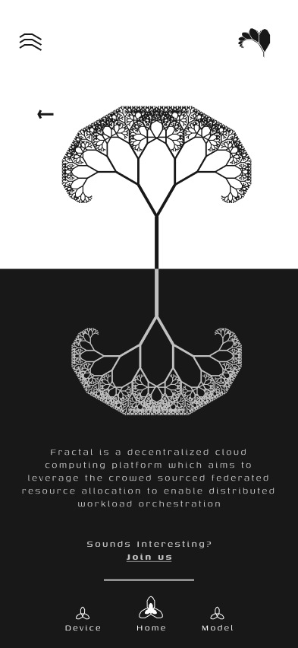  Figure 54- About US UI | 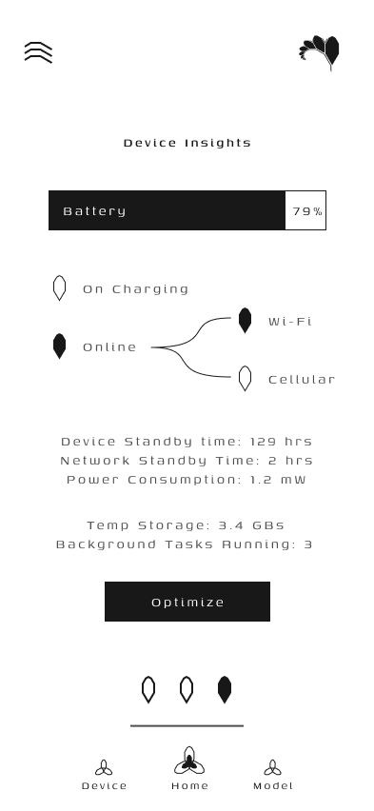  Figure 55 - Device Insight UI

Device registration Forget Password

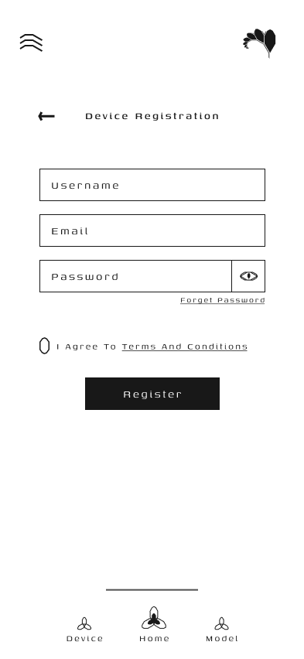  Figure 56 - Device registration UI | 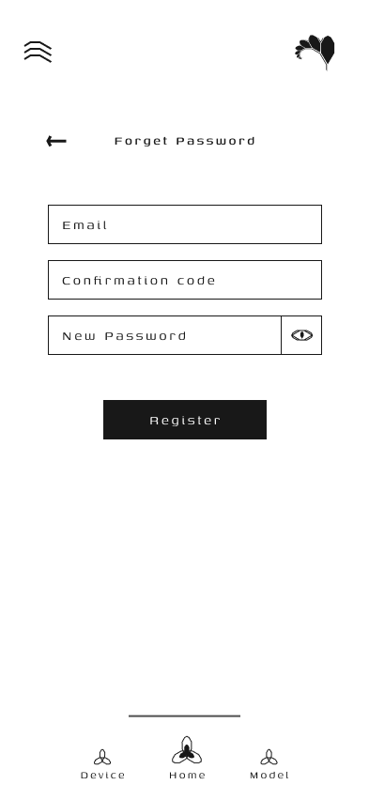  Figure 57 - Forget password UI

Home Active Home Inactive

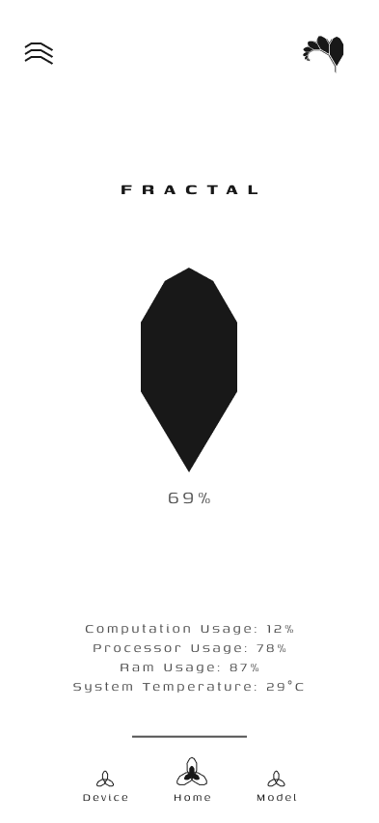  Figure 58 - Active UI | 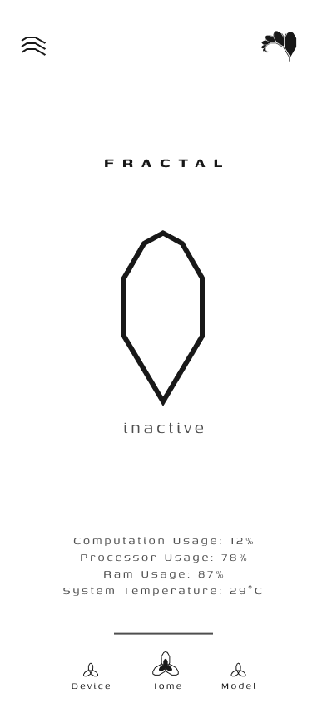  Figure 59 - Inactive UI

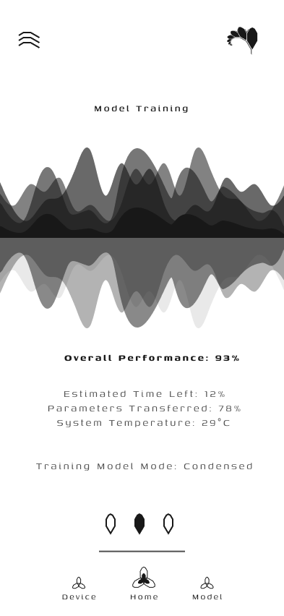  Figure 60 - Model training UI | 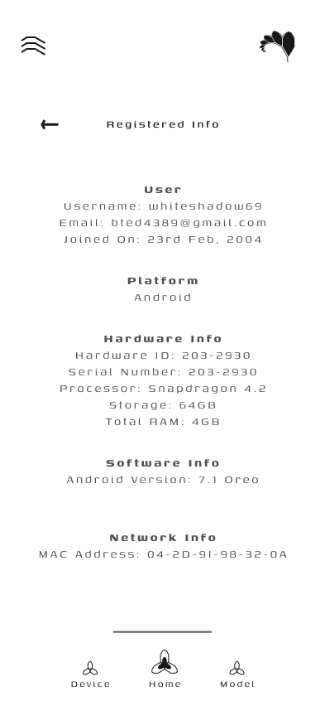  Figure 61 - Registered Info UI
Model Training Registered Info

Setting Screen Unregister Screen

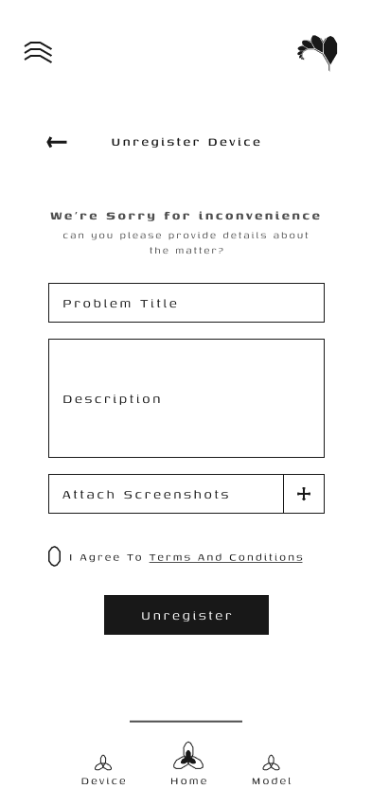
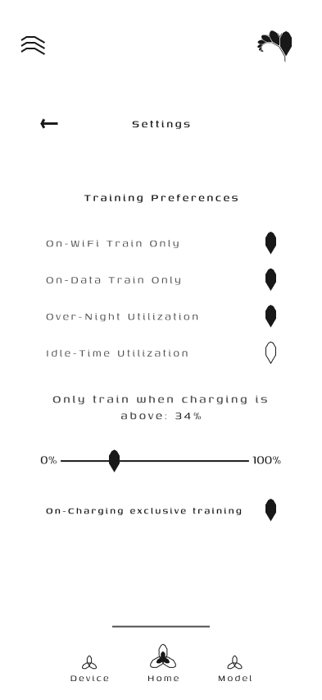
Figure 62 - Unregister UI
Figure 63 - Setting UI

Heartbeat

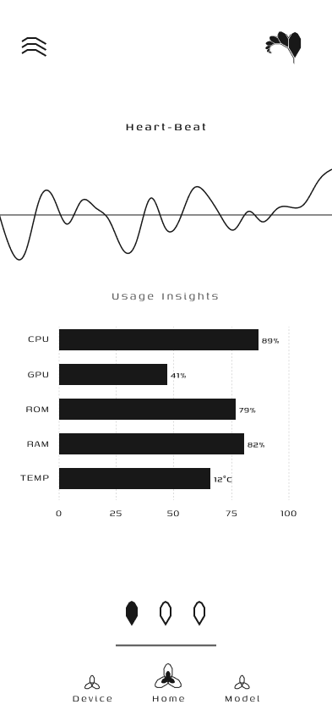
Figure 64 - Heartbeat UI

Server-side dashboard
The server-side dashboard displays the whether server is online or offline, number of clients reported, system metrics, number of rounds, pipeline of task and which is currently on going (initialization, data dispatch, on device training etc.)
The server dashboard is provided below:

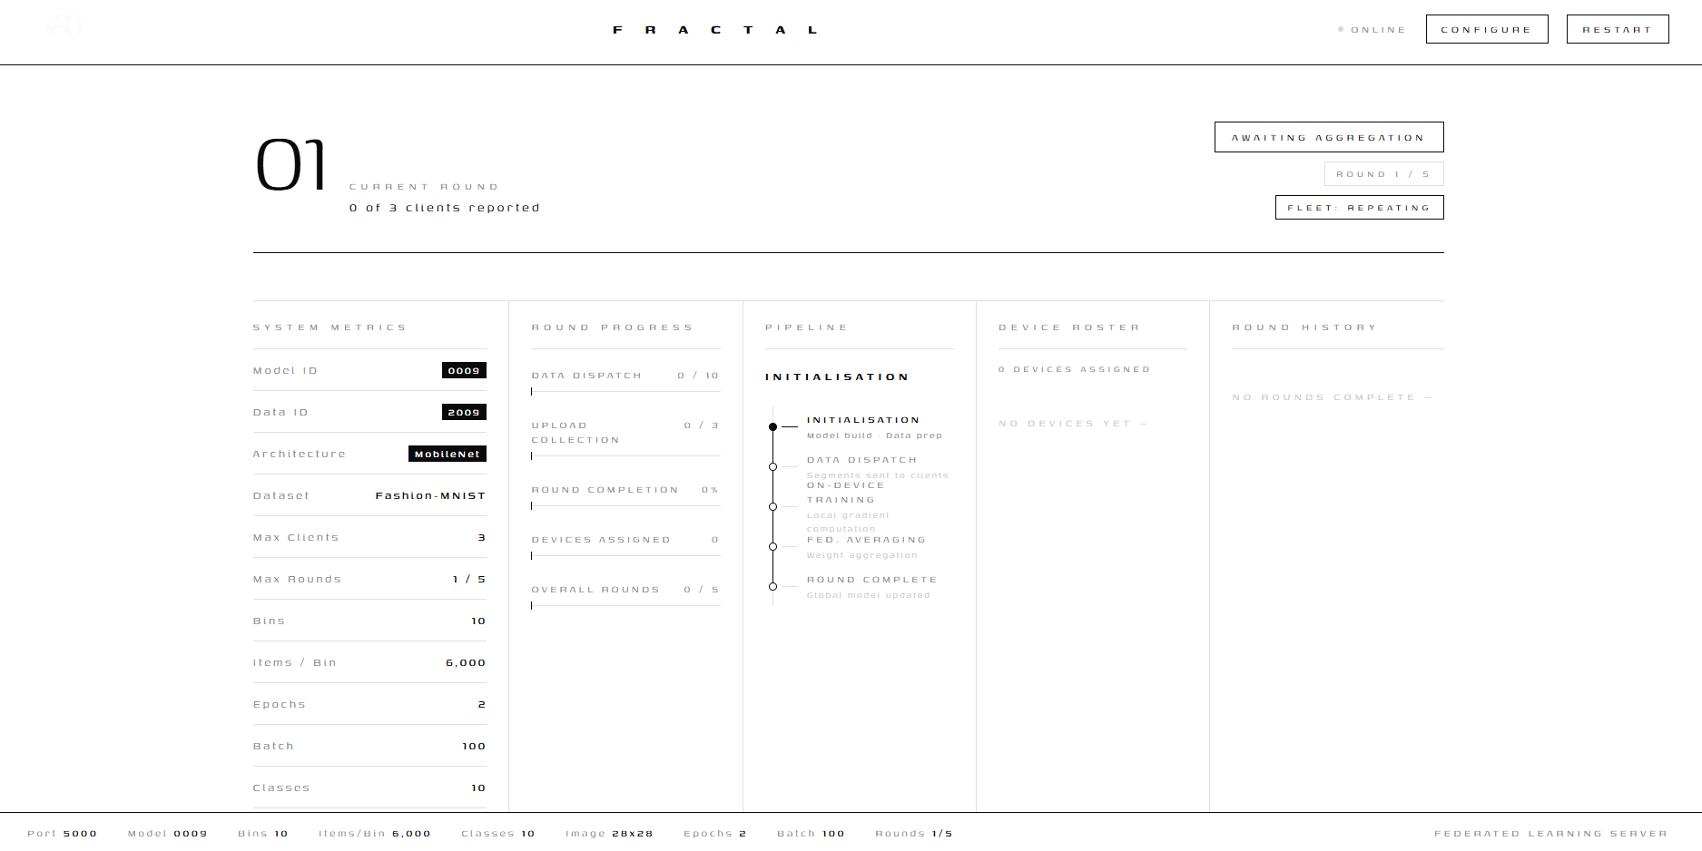

Figure 65 – Server-side dashboard

Testing and Evaluation

Unit Testing
Unit Testing 1: About us components
Testing Objective: To ensure that the all components on click on about us it displays the join us, underline it with different color and on click shift to deice authentication

No. | Test case/Test script | Attribute and value | Expected result | Result
1 | About us screen displays join us link | Launch About us | Display the detail with underline link | Pass
2 | Check the underline Join_us | Observe About us screen | Displayed Join_us with underline link | Pass
3 | Validate the join us link | Click join us | Navigates to device auth screen | Pass

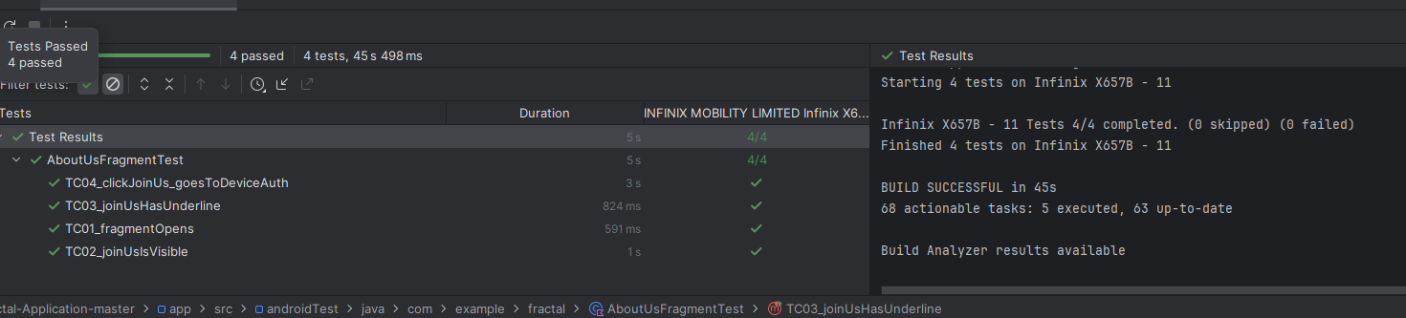

Figure 66 About us test

Unit Testing 2: Get started components
Testing Objective: To ensure working of components that the on click on about us it displays the join us, underline it with different color and on click shift to deice authentication

No. | Test case/Test script | Attribute and value | Expected result | Result
1 | Get started screen displays join us link | Launch Get started | Display the detail with link | Pass
2 | Check the visible Get started | Observe Get started screen | Displayed Get started with Get started link | Pass
3 | Validate the Get started link | Click Get started | Navigates to device Home screen | Pass

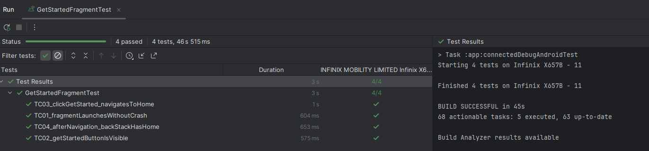

Figure 67 Get started test
Unit Testing 3: Device authorization components
Testing Objective: To ensure that the components as user login or register efficiently considering all conditions and input fields

No. | Test case/Test script | Attribute and value | Expected result | Result
1 | Validates launch of device auth and visibility of all input fields | No input | Displayed all input fields and button | Pass
2 | Check leaving all or either one input field empty | Email, username, password = “Empty”,  Email = “Empty”  username = “Empty”,  password = “Empty”, | Please “Fill all the fields”  Please “Fill all the fields  Please “Fill all the fields”  Please “Fill all the fields | Pass
3 | Validate the work of “forget password” | Click the “forget password” | Navigates to forget password screen | Pass
4 | Check terms & conditions checkbox | Checked  Double click check | Enabled to login/register  unchecked | Pass

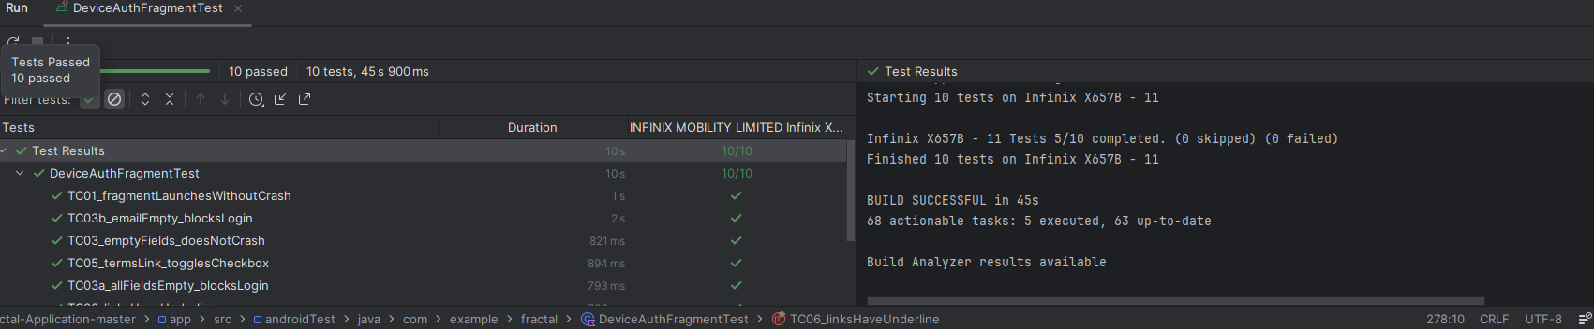

Figure 68 Device authorization test

Unit Testing 4: Setting screen components
Testing Objective: To ensure that the default components setting works, toggle WIFI, update the charging limit and it work accordingly

No. | Test case/Test script | Attribute and value | Expected result | Result
1 | Verify default configuration value | No input | OnWIFI=true, minchargelimit=20,  onData=false etc. | Pass
2 | Check Wi-Fi Toggle by state change | WIFI “on” data “on”  WIFI “on” data “off” | Data still active on WIFI on  WIFI on stay active | Pass
3 | Update charge limit and validate range | Value= 50  Value= 0  Value= 100 | Set the limit when to charge 50, 0 and 100 | Pass
4 | Update charge limit and validate range | Value= -5  Value= 110 | Se reject | Pass
5 | Validate toggle setting overnight, on charge | Call one  Call twice | Return to original | Pass

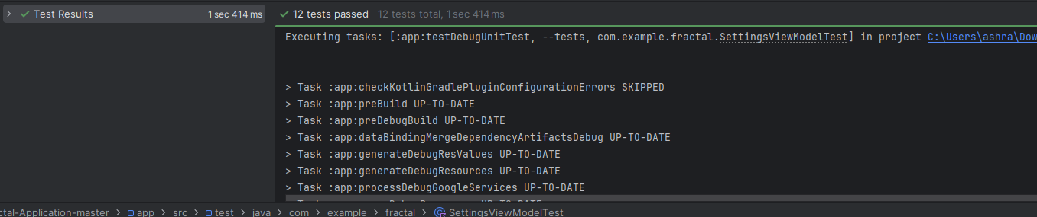
Figure 69 setting screen unit test

Unit Testing 5: Home compnents
Testing Objective: To ensure that the components user is able to active, inactive and pause the training and it displays the resources of the relevant device

No. | Test case/Test script | Attribute and value | Expected result | Result
1 | Check whether all resources info and diamond button visible | Click “Get started” | Diamond toggle button and resources displayed | Pass
2 | Check the impact of first click on toggle button | Status “Inactive” click | Status change !=inactive | Pass
3 | Check another impact on click | Status != server offline  Click | Status change pause or cancel training | Pass
4 | Check another impact on click | Status != waiting for data  click | Status change pause or cancel training | Pass
5 | Verify progress from diamond toggle button | Click diamond button | Within seconds diamond stats to change color to black 1,10,50,70, 100 | Pass
6 | Validate the extend value than range for diamond toggle | diamond.setProgress(-10)  diamond.setProgress(110) | Toggle button didn’t stop or crash | Pass

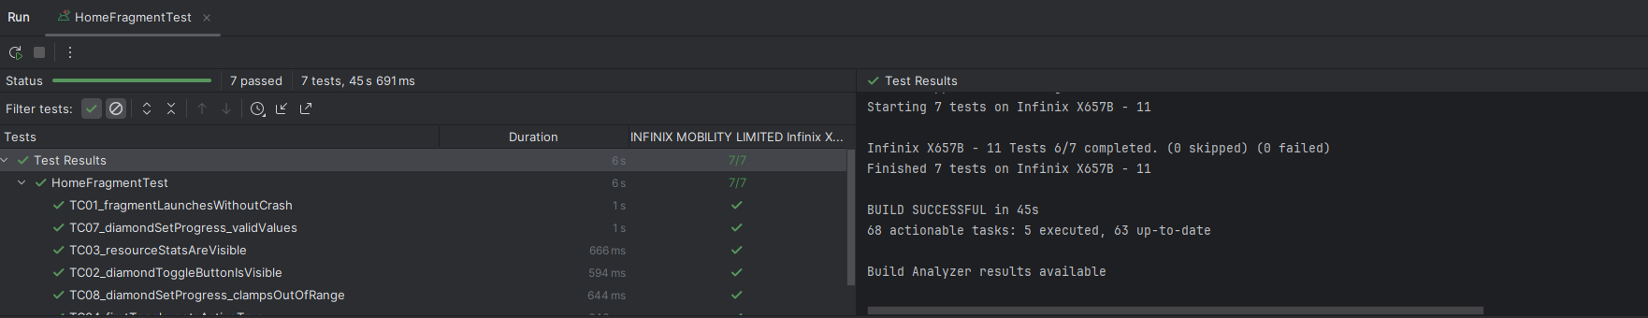
Figure 70 Home testing
Unit Testing 6: Unregister components
Testing Objective: To ensure that the component user be able to unregister the device and submit any problem

No. | Test case/Test script | Attribute and value | Expected result | Result
1 | Check the impact of leaving fields or any single one empty | Title = “” &  decryption = “”,  Title = “” & decryption = “aaaaa”,  Title = “aliali” & decryption = “”, | Unable to unregister/submit | Pass
2 | Check the term uncheck result | Uncheck terms & conditions | unregister/submit | Pass
3 | Validate the work double check the term check box and “back arrow” | Click the “back”  Click the checkbox twice | Navigates to auth screen  Unchecked to unchecked | Pass

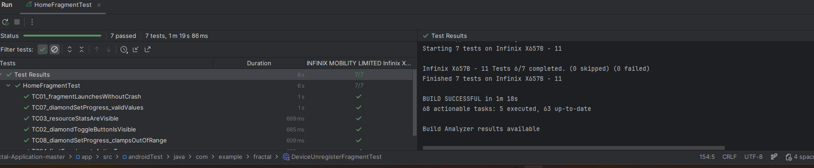
Figure 71 unregister

Unit Testing 7: Usage insight components
Testing Objective: To ensure that the component usage insight such as heartbeat and resource chart visible with their updates

No. | Test case/Test script | Attribute and value | Expected result | Result
1 | Check resource chart set values | CPU=0.8, GPU=0.5, ROM=0.7, RAM=0.6, TEMP=0.4 | Values updated | Pass
2 | Check resource chart set values to boundary values | CPU=0.0, GPU=1.0 | Value updated silently | Pass
3 | Verify heartbeat active | setActive(true)  setActive(false) | View active  inactive state | Pass
4 | Verify hearbeat update with dummy data | updateStats(map) | Accept the input and didn’t crash | Pass

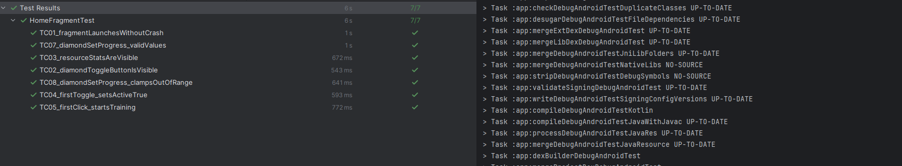
Figure 72 usage insight testing

Unit Testing 8: Model Initialization and Data Loading
Testing Objective: To ensure the model loading and batch data loading functions work correctly with valid and invalid inputs.

No. | Test case/Test script | Attribute and value | Expected result | Result
1 | Check model loading with valid TFLite file | Model file: "model.tflite" (valid asset) | Model loads successfully, interpreter is not null | Pass
2 | Check model loading with invalid file name | Model file: "invalid_model.tflite" | Throws IOException, logs error message | Pass

Unit Testing 9: Batch Loading with Valid/Invalid Batch Index
Testing Objective: To ensure batch loading handles correct skipping and reading of image/label data
No. | Test case/Test script | Attribute and value | Expected result | Result
1 | Load valid batch (e.g., batch 0) | Batch index: 0, Assets: "train_images.bin", "train_labels.bin" | Returns Pair of FloatBuffers with size BATCH_SIZE * IMG_HEIGHT * IMG_WIDTH and BATCH_SIZE * NUM_CLASSES | Pass
2 | Load invalid batch (out of range) | Batch index: NUM_BATCHES + 1 | Returns null, logs error for incomplete read | Pass

Unit Testing 9: Inference with Valid/Invalid Input
Testing Objective: To ensure inference processes correct-sized inputs and handles errors

No. | Test case/Test script | Attribute and value | Expected result | Result
1 | Infer with valid image array | testImage: FloatArray(784) { 0.5f } | Logs predicted class and probability, no errors | Pass
2 | Infer with invalid size array | testImage: FloatArray(100) | Logs error for size mismatch (expected 784), returns early | Pass

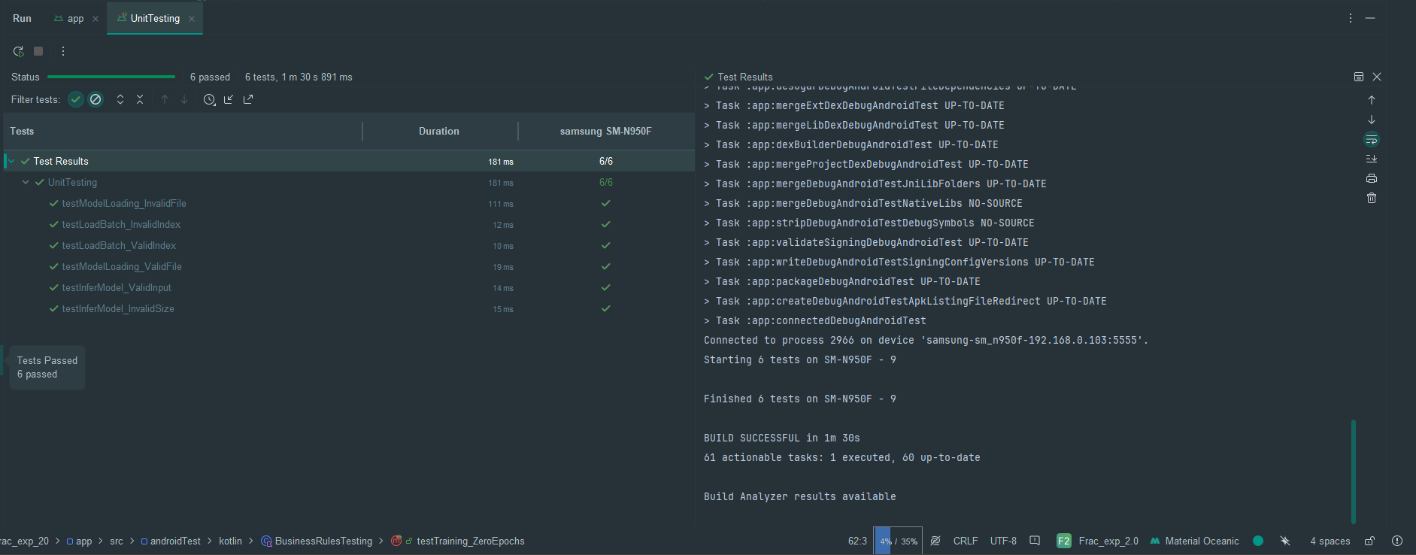

Functional Testing
Functional Testing 1: Get started screen

No. | Test case/Test script | Attribute and value | Expected result | Actual result | Result
1 | Get started with button visible | Open app | Visibility = true  Isenabled = true | Starting screen visible with get started button at bottom | Pass
2 | Get_started button clickable | On get started screen | Clickable =true | Button is clickable | Pass
3 | Tap “Get started” button | On get started screen | Navigation_controller= navigation_home | Navigate to the home screen | Pass

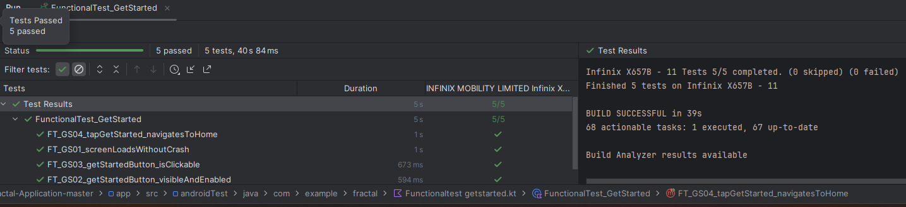
Figure 73 FT get started
Functional Testing 2: Home screen

No. | Test case/Test script | Attribute and value | Expected result | Actual result | Result
1 | Get resource stats visible | On home screen | All resource_visibile = true | home screen visible resources | Pass
2 | Diamond button visible and clickable | On home screen | Clickable =true | Button is clickable | Pass
3 | First tap diamond button | isActive = false | Status!=inactive | Status updated to active, server offline, wait to be idle | Pass
4 | second tap diamond button | inactive = false | Status!=active or server offline | Status paused | Pass
5 | Diamond progress | Set progress (50) | Progress 50 | No exception for valid | Pass

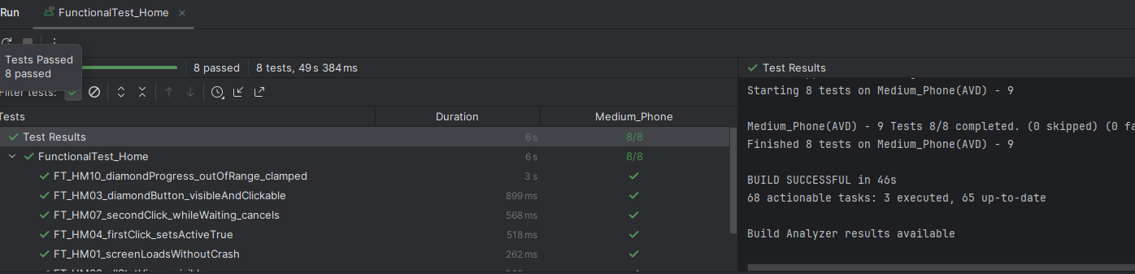

Functional Testing 3: Insight screen

No. | Test case/Test script | Attribute and value | Expected result | Actual result | Result
1 | Get indicators visible | On default screen screen | All indicators_visibile = true | Indicator model, device and home screen visible | Pass
2 | Default page 1 and total 3 | On device insights screen | Currentitem=1 | Device isnight | Pass
3 | Get right side indicator Heartbeat view | Click= right_indicator | Setactive(true) | Actiive the heartbeat view | Pass
4 | Resource chart view | Click= left_indicator | Setactive(true) | Displays CPU, GPU RAM etc | Pass
5 | Diamond progress | Set progress (50) | Progress 50 | No exception for valid | Pass

Functional Testing 4: Full Training Cycle
Objective: To ensure the training process completes epochs with batch loading and loss calculation without crashes.

No. | Test case/Test script | Attribute and value | Expected result | Actual result | Result
1 | Run full trainModel() with default params | NUM_EPOCHS=2, NUM_TRAININGS=6000, BATCH_SIZE=100 | Completes all epochs, logs losses, processes all samples | Training completed, losses logged | Pass
2 | Run trainModel() with null interpreter | interpreter = null | Logs "Interpreter not initialized" and returns early | Error logged, no training attempted | Pass

Functional Testing 5: Weight Restoration and Inference
Objective: To ensure weights can be saved/restored and inference works post-restoration.

No. | Test case/Test script | Attribute and value | Expected result | Actual result | Result
1 | Call restoreWeights() with valid storage | Checkpoint path: Documents/checkpoint.ckpt | Saves/restores weights, logs success, test inference runs | Weights restored, test inference successful | Pass
2 | Call inferModel() after restore | testImage: Dummy zero array (784 floats) | Predicts class with probability, logs result | Predicted class 0, probability ~1.0 | Pass

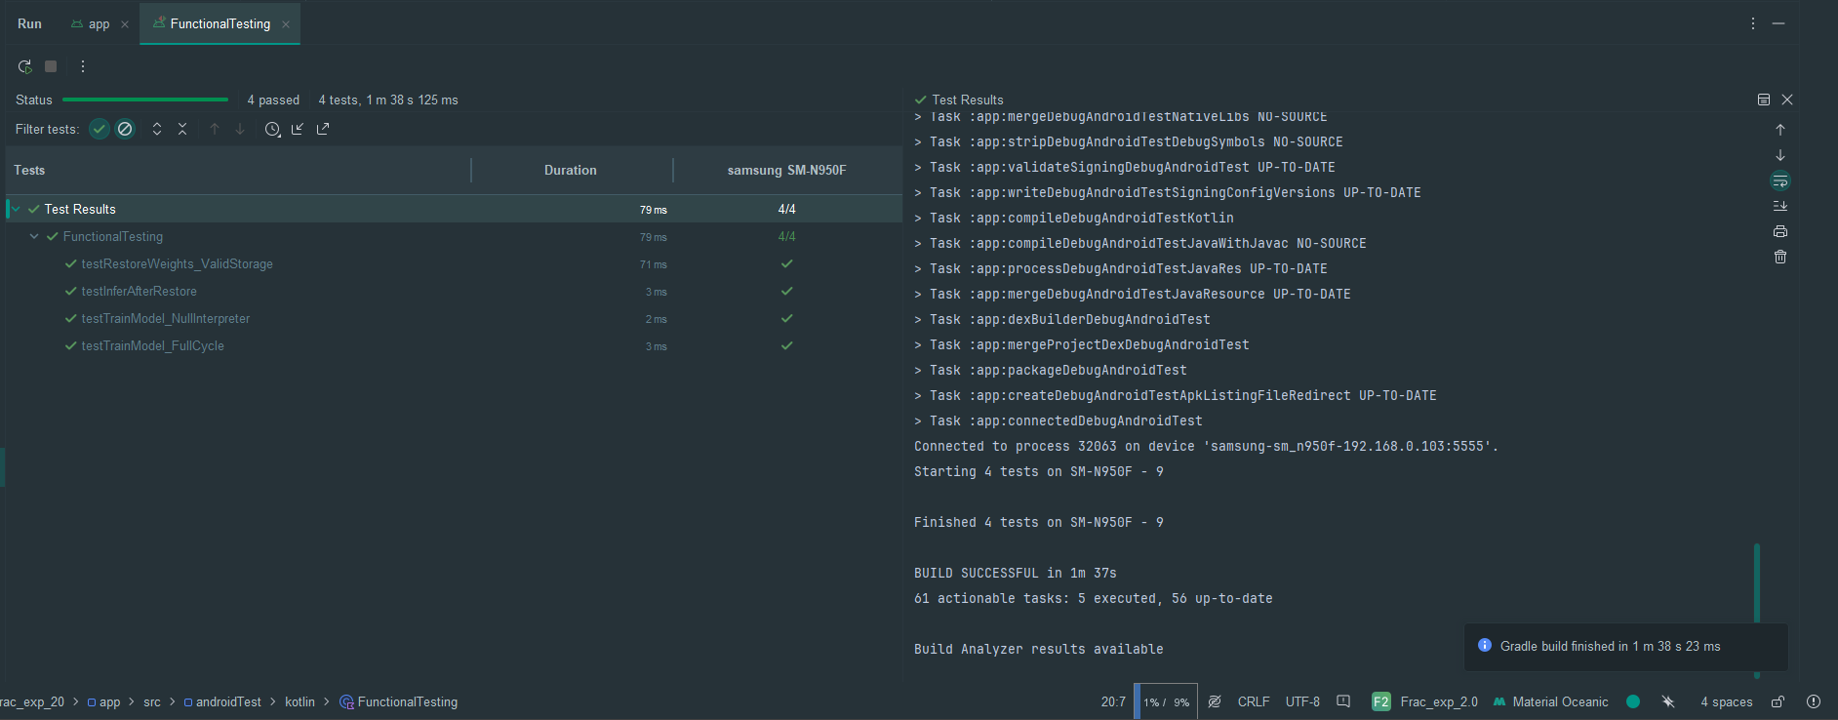

Business Rules Testing
Business Rules Testing 1: Getting started navigation
Objective: Validate business rules for navigating to home screen

Conditions/Rules | Rule 1: Button tapped | Rule 2: Button not tapped | Rule 3: Back pressed
btn_get_started clicked | Y | N | N
Back pressed | N | N | Y
Nav graph actions | Y | Y | Y
Actions/output
Navigate to home | Y | N | N
Stay on nav get started | N | Y | N
Back stack | N | N | Y
Expected Output | Home screen loaded | Stays | App exit

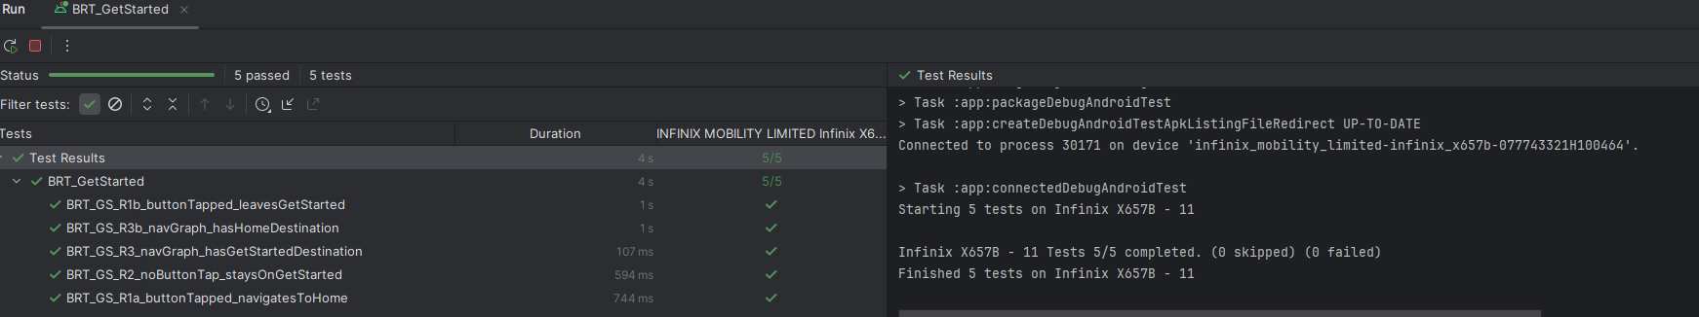

Business Rules Testing 2: Device auth
Objective: Validate business rules for all input fields before auth attempted

Conditions/Rules | Rule 1: All valid | Rule 2: invalid email | Rule 3: invalid username | Rule 4: term not accepted | Rule 4: invalid password
Username | Y | Y | N | Y | Y
email | Y | N | Y | Y | Y
Password | Y | Y | Y | Y | N
Term and condition checked | Y | Y | Y | N | Y
Actions/output
Et_email: error | N | Y | N | N | N
Et_username: error | N | N | Y | N | N
Et_password: error | N | N | N | N | Y
Please accept terms | N | N | N | Y | N
Btn_text= auth | Y | N | N | N | N
Proceed to server | Y | N | N | N | N
Expected Output | Auth proceed | Email field error | username field error | terms field error | password field error

Business Rules Testing 3: Device unregister
Objective: Validate business rules for all input fields before auth attempted

Conditions/Rules | Rule 1: feedback | Rule 2: feedback unregister | Rule 3: invalid/empty title | Rule 4: term not checked
problem | Y | Y | N | Y
Description | Y | Y | Y | Y
Term and condition checked | Y | Y | Y | N
Unregister checked | N | Y | N | N
Actions/output
Feeback submitted | Y | Y | N | N
Device unregistered | N | Y | N | N
Error: empty | N | N | Y | N
Please accept terms | N | N | N | Y
Btn_submit | - | - | Y | Y
Expected Output | Feedback sent | Feedback sent + unregister | field error | terms field error

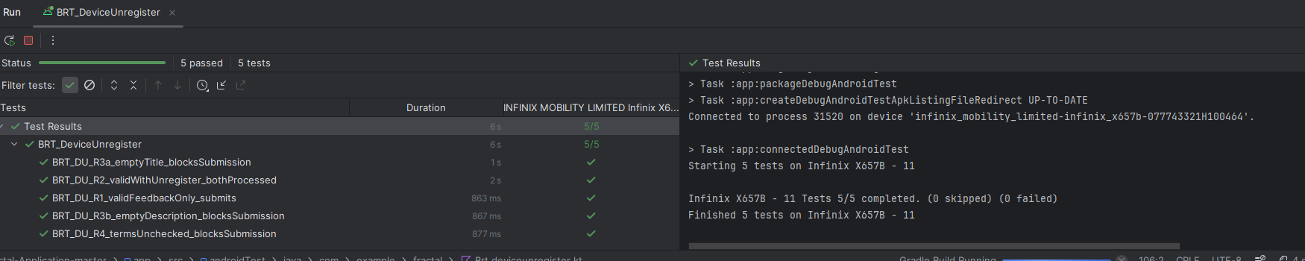

Business Rules Testing 4: Training Parameter Validation
Objective: Validate business rules for training parameters (e.g., batch size divisibility, epoch limits).

Conditions/Rules | Rule 1: Valid Params | Rule 2: Invalid Batch | Rule 3: Zero Epochs | Actions/Outputs
NUM_EPOCHS > 0 | Y | Y | N | Proceed to training
NUM_TRAININGS % BATCH_SIZE == 0 | Y | N | Y | Full batches processed
BATCH_SIZE > 0 | Y | Y | Y | Batches loaded correctly
Expected Output | Training completes | Logs warning for incomplete batch | Skips training loop | -

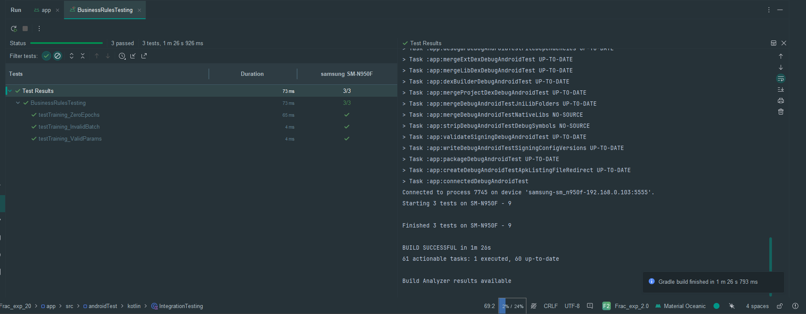

Integration Testing
Integration Testing 1: End-to-End Training and Inference
Testing Objective: To ensure integration between data streams, model interpreter, training, and inference modules works seamlessly.

No. | Test case/Test script | Attribute and value | Expected result | Actual result | Result
1 | Train then infer | Call trainModel(), then inferModel(FloatArray(784)) | Training completes, inference predicts on trained model | Loss decreases over epochs, valid prediction logged | Pass
2 | Restore then train | Call restoreWeights(), then trainModel() | Weights load correctly, training resumes without errors | Restoration successful, training proceeds | Pass

Integration Testing 2: Resource Cleanup
Testing Objective: To ensure cleanup integrates with interpreter and streams without leaks.
No. | Test case/Test script | Attribute and value | Expected result | Actual result | Result
1 | Train, infer, then cleanup | Full cycle + cleanup() | Interpreter and streams closed, no exceptions | Resources freed, no leaks in logs | Pass
2 | Multiple cleanups | Call cleanup() twice | Second call safe, no crashes | Ignores second call gracefully | Pass

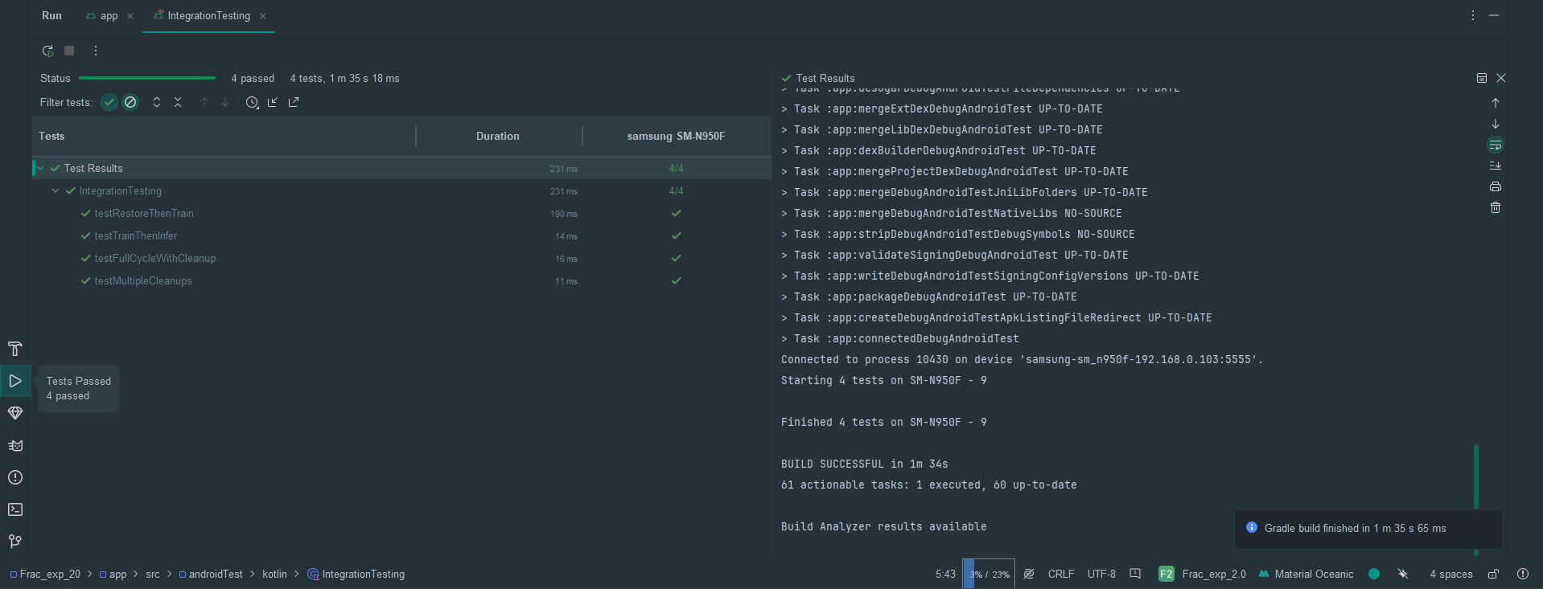

Conclusion and Future Work
This conclusion and future work section demonstrates the successfully implemented decentralized distributed computation harvesting platform and the future enhancements going to happen in the platform

Conclusion
Fractal a decentralized distributed computation harvesting system demonstrates the utilization of computational power of mobile devices for model training. In this platform, computationally intensive task was divided into smaller chunks and distributed among the active idle mobile phone devices. Each device performs the assigned task locally for a fixed duration. After the duration, the processed data from the devices were be retrieved, aggregated, and federated into a single unit. The system demonstrated the feasibility of utilizing idle devices making it efficient, low-cost, and energy-efficient approach to providing resources than traditional ones. This project highlights the innovation of using idle mobile devices for training purposes.
Overall, the Fractal prove that mobile based computation harvesting is feasible, ecofriendly and especially for small AI/ML companies or organizations, independent researchers can be cost effective

Future Work
The current functionality of FRACTAL demonstrates the core functionality of the system, several features can be enhanced and added in the system like:
- The fractal is currently a computation harvesting platform for android devices only but in future we extend the devices including IOS and IOT
- To engage the user, we will implement the reward-based system just like Microsoft edge (daily login points, search points mean usage points combine to redeem the vouchers such as Shopon etc.). In this system, on daily login and usage of the application like activation of the access to train the model, the user gets points through which user redeems the vouchers
- Enhance the security of model transmission so that devices remain safe from malicious updates
- Enhance the scalability of the system to make it efficient in real world circumstances

References
[1] Adnan Mehonic, A. k. (2021). Brain-inspired computing: We need a master plan. researchgate. Retrieved from https://www.researchgate.net/publication/351221765_Brain-inspired_computing_We_need_a_master_plan

[2] Anderson., D. D. (n.d.). Retrieved from BONIC: https://boinc.berkeley.edu/

[3] Aslan, M. (2023). The Views of EFL Preparatory Students on the Use of Mobile Devices in Language Learning. Reearchgate. Retrieved from https://www.researchgate.net/publication/371491269_The_Views_of_EFL_Preparatory_Students_on_the_Use_of_Mobile_Devices_in_Language_Learning
[4] Bai, W., Jia, J., Deng, T., & Dong, M. (2024). Distributed Machine Learning with Electric Vehicles in Parking Lots. 2024 International Joint Conference on Neural Networks (IJCNN). Yokohama: IEEE. Retrieved from https://ieeexplore.ieee.org/document/10651414

[5] Jane Theirs, F. e. (2025, January 9). California wildfires raise alarm on water-guzzling AI like ChatGPT. Retrieved from Fortune: https://fortune.com/article/how-much-water-does-ai-use/

[6] Katherine Saltzman, J. m. (2025, July). How data centers have come to matter: Governing the spatial and environmental footprint of the “digital gateway to Europe”. researchgate. Retrieved from https://www.researchgate.net/publication/382094232_How_data_centers_have_come_to_matter_Governing_the_spatial_and_environmental_footprint_of_the_digital_gateway_to_Europe

[7] Marin, D. (n.d.). Retrieved from NEXUS: https://nexus.xyz/network

[8] Thomas Gabor, F. r. (2020). The Holy Grail of Quantum Artificial Intelligence: Major Challenges in Accelerating the Machine Learning Pipeline. researchgate. Retrieved from https://www.researchgate.net/publication/341039795_The_Holy_Grail_of_Quantum_Artificial_Intelligence_Major_Challenges_in_Accelerating_the_Machine_Learning_Pipeline

